CSS GENDER STUDIES
T5KB
The Knowledge Base
Topic 5 · Status of Women in Pakistan — health, education, employment and law, taught from zero
WHAT THIS DOCUMENT GIVES YOU
◆ Syllabus Head VI taught from zero in simple English — the status of women in Pakistan in health, education, employment and law
◆ How status is measured — the Global Gender Gap Report 2025 and 2026, and why Pakistan ranks so low
◆ Maternal health and Fathalla's "road to maternal death"
◆ education gaps
◆ the double burden of paid work
◆ The Constitution, family law, protective laws, human rights and the enforcement gap
◆ Intersectional disadvantage, the digital gender gap and climate impacts
◆ Evidence and current data inside every point, diagrams, today's debates, the record and five likely questions
◆ About 120 MCQ-style one-liners, every past MCQ on the topic, and a detailed revision sheet
Federal Public Service Commission · CSS Competitive Examination · Optional paper, 100 marks
Written for CE-2027 onwards · Record: CE-2016 to CE-2026 · Facts current to September 2026

Contents
HOW TO BUILD THE CONTENTS
The contents list below fills itself in. When Word asks "This document contains fields that may refer to other files. Update the fields?", click Yes.
If it does not ask: right-click the grey contents area → Update Field → Update entire table → OK. On a Mac, Control-click the same area. Or press Ctrl + A, then F9 (Windows), to update every field at once. Repeat after any edit, before you export to PDF.

Right-click here and choose Update Field to build the contents.

How to Use This Document

What this topic covers
Topic 5 is syllabus Head VI — Status of Women in Pakistan. The syllabus names four lines: women's health, education, employment and law. The examiner has added three newer ones: Pakistan's gender-gap ranking (2018, 2026), intersectional disadvantage (2026) and the digital gender gap (2026). This document teaches all seven, and adds women's political status and climate impacts in brief.
In the descriptive paper Topic 5 has had 8.5 visits: eight full questions and one short note. Health is the favourite line (2017, 2023, 2024); education has never been a full question — the clearest blind spot in the paper. The topic also supplies 19 of the 140 MCQs, mostly on laws and dates: MFLO 1961, the harassment law 2010, the Women's Protection Act 2006, the NCSW 2000.
This topic feeds every other. Whenever you need a figure, a law or an institution for an answer on development (Topic 4), governance (Topic 6) or violence (Topic 7), it is here.
IN SIMPLE WORDS
"Status" means a person's position in society — what rights, resources, respect and power she has compared with others. To judge women's status in Pakistan, ask four questions: Is she healthy? Is she educated? Can she earn? Does the law protect her — in practice, not only on paper?

How this document is built
1. Part Zero gives you the words of the topic, the four dimensions of status, and the constitutional framework.
2. Part One has ten chapters: measuring status (1); health and maternal health (2–3); education (4); employment (5); the Constitution and family law (6); protective laws, human rights and the enforcement gap (7); intersectional disadvantage (8); the digital gender gap (9); and political status and climate (10).
3. Part Two sets out today's debates.
4. Part Three lists every past question, what the record shows, and five likely questions.
5. Part Four is a bank of about 120 one-liners, followed by every past MCQ on the topic.
6. Part Five is the revision sheet.

Part Zero — The ABC of Topic 5

0.1 The words of this topic
Table 1 · The key terms of Topic 5 (★ = you must be able to define it in one sentence).
Term | Simple meaning, with an example
Status of women ★ | Women's position in society — rights, resources, respect and power — compared with men's.
Global Gender Gap Index ★ | The World Economic Forum's yearly ranking of countries on economic participation, education, health and political empowerment (since 2006).
Maternal mortality ratio (MMR) ★ | Deaths of women from pregnancy or childbirth per 100,000 live births. Pakistan: 186 (2019).
Antenatal care | Health check-ups during pregnancy.
Skilled birth attendant | A trained doctor, nurse or midwife who helps at childbirth.
Anaemia | Lack of healthy red blood cells, often from iron deficiency; common among pregnant women.
Stunting | Children too short for their age because of long-term undernutrition.
Total fertility rate | The average number of children a woman has in her lifetime.
Lady Health Worker (LHW) ★ | A community health worker who provides basic health and family-planning care door to door (programme from 1994).
Literacy rate ★ | The share of people who can read and write. Census 2023: about 68% men, 53% women.
Out-of-school children | Children of school age not enrolled — more than 25 million in Pakistan, most of them girls.
Labour-force participation rate (LFPR) ★ | The share of working-age people who work or seek work. Women: 24.4% (LFS 2024–25).
Informal sector | Work without legal protection or social security — home-based, domestic, unpaid family work.
Double burden ★ | Paid work plus unpaid housework and care — the "second shift".
Glass ceiling ★ | Invisible barriers that stop women rising to the top (MCQ 2024).
Sticky floor | Women stuck in low-wage, low-mobility jobs (MCQ 2026).
Comparable worth | Equal pay for work of equal value; its absence means women's jobs are paid less (MCQ 2023).
Gender pay gap | The difference between men's and women's average earnings.
Fundamental rights | Rights guaranteed in the Constitution (Articles 8–28), enforceable in court.
Principles of Policy | Goals the state should pursue (Articles 29–40), not directly enforceable.
Muslim Family Laws Ordinance ★ | The 1961 law on marriage registration, polygamy, divorce and orphaned grandchildren's inheritance.
Khula | Divorce sought by the wife through a court.
Haq mehr | The marriage gift (dower) owed by the husband to the wife.
Enforcement gap ★ | The distance between laws on paper and their application in practice.
NCSW ★ | National Commission on the Status of Women, set up in 2000 under Pervez Musharraf.
Intersectionality ★ | Overlapping identities — gender, class, place, religion, disability — that create unique disadvantage.
Digital gender gap ★ | The difference between men's and women's access to and use of phones and the internet.
Reserved seats | Seats for women in legislatures: 60 in the National Assembly.

0.2 The four dimensions of women's status
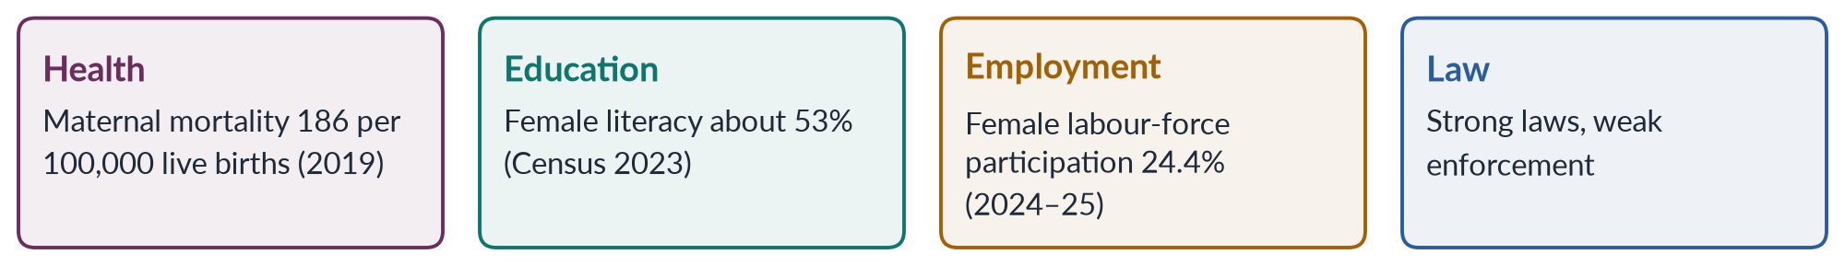
Figure 1 · The four syllabus dimensions of women's status, with Pakistan's headline figure.

0.3 The constitutional framework
✦ LAW & POLICY
Constitution of Pakistan 1973 · the articles on women
• Article 25: all citizens are equal before law; no discrimination on the basis of sex; the state may make special provision for women and children.
• Article 25A: free and compulsory education for children aged 5 to 16 (added by the 18th Amendment, 2010).
• Articles 26–27: no discrimination in access to public places or in public service on the basis of sex.
• Article 32: representation of women in local government.
• Article 34: steps to ensure full participation of women in all spheres of national life.
• Article 35: the state shall protect the marriage, the family, the mother and the child.
• Article 37(e): just and humane conditions of work, and maternity benefits for women in employment.
• Articles 51, 59, 106: reserved seats for women in the National Assembly, Senate and provincial assemblies.

EXAMINER'S EYE · HOW THE EXAMINER USES THIS TOPIC
The examiner asks you to describe women's status and then to explain and improve it: "How could it be improved within the available economic resources?" (2017); "What reasons are responsible…?" (2018); "What measures could be taken?" (2023); "Identify the factors…" (2026). A status answer without causes and solutions is half an answer. Learn, for each dimension: (1) the latest data; (2) the causes; (3) the laws and programmes; (4) the way forward.

Part One — The Status of Women in Pakistan

Chapter 1 · Measuring Women's Status: The Global Gender Gap and Pakistan
Two questions asked why Pakistan ranks so low: "What reasons are responsible for ranking Pakistan as the second-worst country in the world for gender inequality despite… the 1973 Constitution?" (2018) and "Evaluate Pakistan's performance in the World Economic Forum's Global Gender Gap Report 2025… Identify the socio-economic and political factors" (2026). A 2024 MCQ asked Pakistan's rank in 2023 (142nd of 146).

1.1 How women's status is measured
Women's status cannot be seen in one number, so international bodies combine several indicators into an index.
Table 2 · The main international measures of women's status.
Index | Publisher | What it measures
Global Gender Gap Index (GGGI) | World Economic Forum, since 2006 | Gaps between women and men in economic participation and opportunity, educational attainment, health and survival, and political empowerment
Gender Inequality Index (GII) | UNDP, since 2010 | Reproductive health, empowerment and labour-market gaps
Gender Development Index (GDI) | UNDP, since 1995 | Women's human development compared with men's
Women, Business and the Law | World Bank | Legal equality in areas such as work, pay, marriage and assets
SDG 5 indicators | UN | Progress on the gender goal's targets

1.2 The Global Gender Gap Index explained
✦ DEFINITION
Global Gender Gap Index · World Economic Forum
A yearly score from 0 to 1 (or 0–100%) showing how much of the gap between women and men a country has closed across four sub-indices: economic participation and opportunity, educational attainment, health and survival, and political empowerment. A score of 100% would mean full parity. It measures gaps, not absolute levels — a poor country can score well if women and men are equally poor.

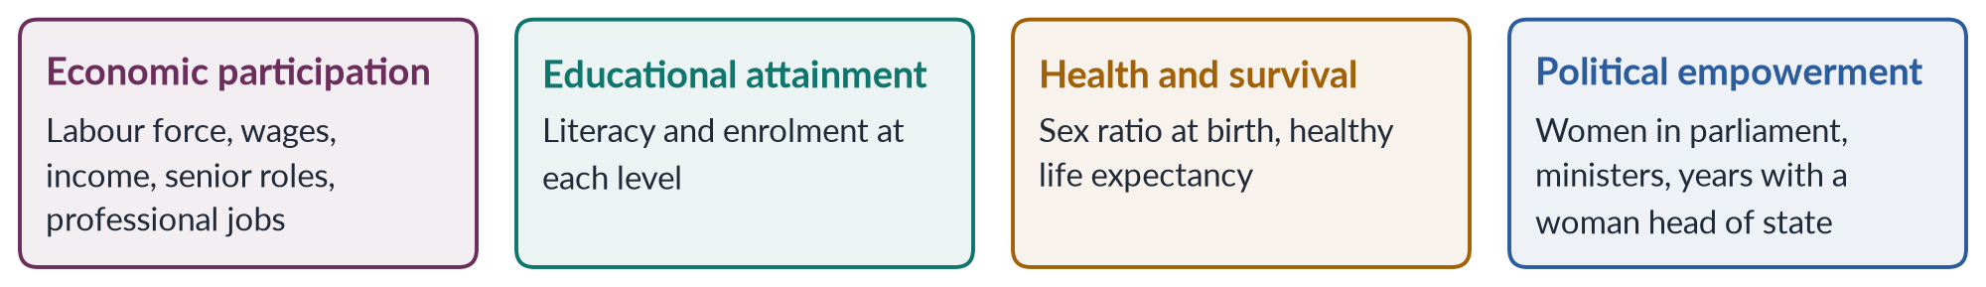
Figure 2 · The four sub-indices of the Global Gender Gap Index.

1.3 Pakistan's record
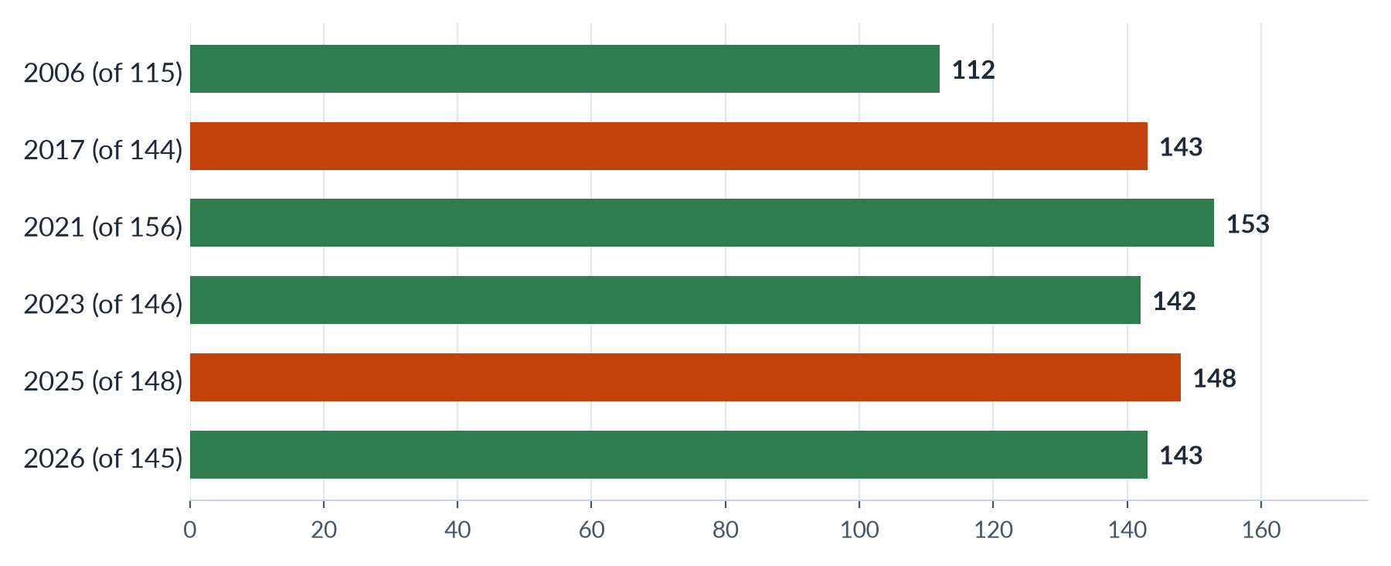
Figure 3 · Pakistan's rank in the Global Gender Gap Report (lower is better; out of the countries shown).
✦ DATA
Global Gender Gap Report 2025 · World Economic Forum
Pakistan ranked 148th of 148 — last — with 56.7% of its gender gap closed (about 57% in 2024). The share of women among government ministers fell to zero. The report recorded a small rise in female literacy.

✦ DATA
Global Gender Gap Report 2026 · World Economic Forum
Pakistan rose to 143rd of 145, with 59.5% of the gap closed — its strongest gain in a decade. Sub-index ranks: economic participation 144th, educational attainment 130th, political empowerment 107th. It was still the lowest of the seven South Asian countries and of 38 lower-middle-income economies. The global gap was 69.2% closed, with parity 120 years away; Iceland ranked first for the 17th year.

In 2017 Pakistan ranked 143rd of 144 — "second-worst", the basis of the 2018 question.

1.3a Reading Pakistan's record over time
When the index began in 2006, Pakistan ranked 112th of 115. Its score rose slowly over the next two decades as girls' enrolment and women's political representation grew — the 60 reserved seats of 2002 helped the political sub-index. But its rank often fell, because other countries improved faster and more countries were added. In 2017 it was 143rd of 144 ("second-worst"), in 2021 153rd of 156, in 2023 142nd of 146 (MCQ 2024), and in 2025 last of 148. The 2026 jump to 143rd of 145 came mainly from education and political empowerment, each up 11 places.
The lesson for an exam answer is to distinguish rank (relative to others) from score (absolute progress). Pakistan has made slow absolute progress, but others have moved faster.

1.4 Why Pakistan ranks so low — the four sub-indices

(1) Economic participation — the biggest gap
- Female labour-force participation is only 24.4% (LFS 2024–25), against roughly 80% for men.
- Women earn far less; the ILO has reported one of the widest gender pay gaps in the world for Pakistan.
- Very few women are managers, legislators or senior officials.
- Most working women are in agriculture and the informal sector, much of it unpaid.

(2) Educational attainment
- Female literacy is about 53% against about 68% for men (Census 2023).
- More than 25 million children are out of school, most of them girls.
- Gaps are widest in rural areas and in Balochistan and parts of Khyber Pakhtunkhwa.

(3) Health and survival
- A skewed sex ratio and son preference; the maternal mortality ratio was 186 (2019); high anaemia and malnutrition among women.

(4) Political empowerment
- Women's presence in the National Assembly rests mainly on 60 reserved seats; only 11 women won general seats in 2024.
- In 2025 there were no women ministers; a woman became chief minister of Punjab in 2024.

1.5 "Despite the Constitution and conventions" — why commitments have not closed the gap (2018)
Pakistan's Constitution (Articles 25, 34) promises equality, and it has joined CEDAW (1996), the Beijing Platform (1995) and the SDGs (2015). Yet the gap persists. The reasons:
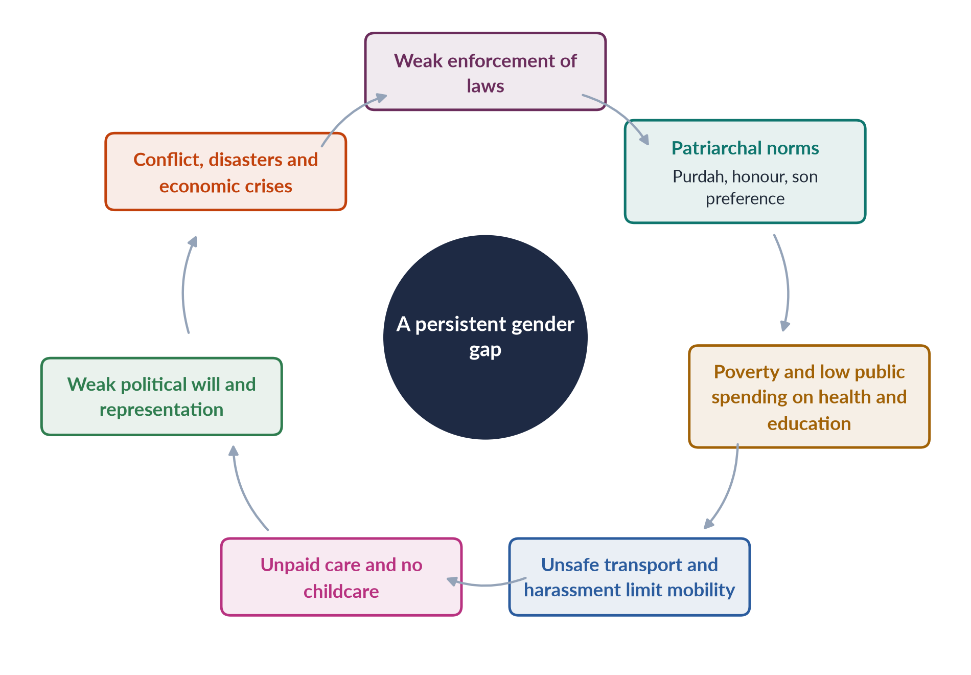
Figure 4 · Why commitments have not closed Pakistan's gender gap.
1. The enforcement gap. Laws exist on paper; police, courts and local officials often do not apply them.
2. Patriarchal social norms — purdah, family honour, son preference, early marriage — limit girls' schooling, women's mobility and work.
3. Poverty and low spending. Public spending on health and education has long been low — each only about 1–2% of GDP — so services are weak, especially for rural women.
4. Mobility and safety. Unsafe transport and harassment keep women out of work and study.
5. Unpaid care. Without childcare, women carry most household and care work.
6. Political will and voice. Few women in elected office; gender often low on the agenda.
7. Crises. Conflict in the north-west (attacks on girls' schools), the 2022 floods and economic crises hit women hardest.
8. Reservations and uneven federalism. After the 18th Amendment (2010), women's development moved to the provinces, whose capacity and laws differ.

1.5a Pakistan in South Asia
Pakistan has usually ranked last in South Asia in the Global Gender Gap Report. Neighbours with similar incomes and cultures have done better in particular areas:
- Bangladesh has had far higher female labour-force participation, driven by the export garment industry, and has long had women heads of government.
- Sri Lanka has near-universal female literacy and good maternal health, the result of decades of public spending on schools and clinics.
- Nepal raised women's political representation through quotas in its 2015 constitution.
The comparison shows that Pakistan's low ranking is not fixed by religion or region: policy choices — spending on girls' schools and clinics, jobs that women can reach safely, quotas and their enforcement — make the difference.

1.5b What would move Pakistan up the index
Because the index measures gaps, Pakistan's rank would rise fastest with changes in the economic sub-index, where it is weakest.
1. More women in paid work — through safe transport, childcare, enforcement of the harassment law and home-based and digital work with protection.
2. Closing the pay gap — minimum wages enforced for women; equal pay for work of equal value.
3. Women in senior posts — in the civil service, business and boards.
4. Girls' secondary education — to close the enrolment gap after primary school.
5. Maternal and child health — skilled birth attendance and nutrition.
6. Women ministers and elected women — the 2025 fall to zero women ministers cost Pakistan heavily; appointing women to cabinet is one of the quickest ways to improve the political score.
IN SIMPLE WORDS
The index is like a report card with four subjects. Pakistan is failing worst in one subject — economic participation. Improving that subject would lift the overall grade more than anything else.

1.6 Critiques of the index
BALANCED VIEW · HOW FAR SHOULD WE TRUST THE RANKING?
• For: it is consistent over time, uses official data, and compares countries on the same basis; it draws attention to Pakistan's economic gap.
• Against: it measures gaps, not well-being; small data changes can move ranks sharply; it misses violence, unpaid care and informal work; data for Pakistan can be dated.
➜ Line to take: the ranking is a signal, not the whole story; Pakistan's rise in 2026 is welcome, but its economic gap remains among the world's widest.

EXAMINER'S EYE · THE MODEL STRUCTURE FOR 2026 Q4
1. Introduction: the index, its four sub-indices; Pakistan 148/148 (56.7%) in 2025 and 143/145 (59.5%) in 2026. 2. Economic participation — LFPR 24.4%, pay gap, informal work. 3. Education — literacy 53/68, out-of-school girls. 4. Health — MMR 186, anaemia, sex ratio. 5. Political empowerment — 11 women on general seats, no women ministers in 2025. 6. Socio-economic factors (poverty, norms, mobility, care). 7. Political factors (will, enforcement, federalism). 8. Critique of the index. 9. Way forward. 10. Conclusion. Draw the bars figure.

Chapter 2 · Women's Health in Pakistan
Health is the favourite line of Topic 5: "What is the status of women's health in Pakistan? How could it be improved within the available economic resources?" (2017); "Elucidate the current health status of women in Pakistan. What measures could be taken to improve women's status as a whole?" (2023). Maternal health and the 2024 question are in Chapter 3.

2.1 What "women's health" includes
Women's health is not only maternal health. It covers the whole life cycle:
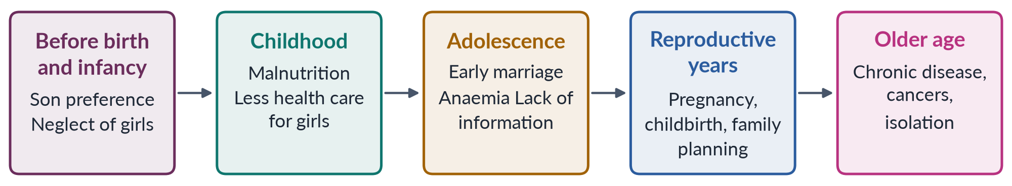
Figure 5 · Women's health across the life cycle.
The World Health Organization defines health as "a state of complete physical, mental and social well-being and not merely the absence of disease or infirmity" (Constitution of WHO, 1946).

2.2 The current status — key indicators
Table 3 · Women's health in Pakistan — key indicators.
Indicator | Value | Source
Maternal mortality ratio | 186 per 100,000 live births | Pakistan Maternal Mortality Survey 2019
Anaemia among women of reproductive age | about 42% | National Nutrition Survey 2018
Stunting among children under five | about 40% | National Nutrition Survey 2018
Total fertility rate | about 3.6 children per woman | PDHS 2017–18
Contraceptive prevalence (modern and traditional methods) | about 34% of married women | PDHS 2017–18
Births assisted by a skilled provider | about two-thirds | PDHS 2017–18
Public spending on health | around 1% of GDP | Economic Survey (various years)

2.3 The main health problems of women
1. Maternal ill-health and death — from haemorrhage, hypertension, infection and unsafe abortion (Chapter 3).
2. Malnutrition and anaemia — women often eat last and least; anaemia weakens women and raises the risk of death in childbirth.
3. High fertility and short birth spacing — many pregnancies close together exhaust women's bodies.
4. Early marriage and adolescent pregnancy — girls married young face higher risks in childbirth.
5. Reproductive tract infections and fistula — often untreated because of shame and lack of female doctors.
6. Cancers — breast cancer is a major killer; a 2019 CSS paper cited about 13,000 deaths a year (MCQ 2019); cervical cancer is also common. Late diagnosis is frequent.
7. Non-communicable diseases — diabetes, heart disease and hypertension are rising.
8. Mental health — depression and anxiety are common among women, linked to violence, isolation, poverty and lack of autonomy; services are scarce and stigma high.
9. Violence — domestic violence causes injury, disability and psychological harm (Topic 7).
10. Disasters and heat — the 2022 floods left about 650,000 pregnant women in affected areas (UNFPA).

2.3a Cancers among women
Breast cancer is the most common cancer among Pakistani women, and it is often diagnosed late, when treatment is harder. Reasons include shame about discussing the breast, lack of awareness of warning signs, too few screening facilities and female radiologists, and the cost of treatment. Pakistan observes Breast Cancer Awareness Month each October, and campaigns such as "Pink Ribbon" promote self-examination and early screening. Cervical cancer, largely preventable through HPV vaccination and screening, is another major cause of death; Pakistan began introducing the HPV vaccine for girls through its immunisation programme in 2025. Early detection through primary care and women health workers is the most cost-effective response.

2.4 Why women's health is poor — the causes
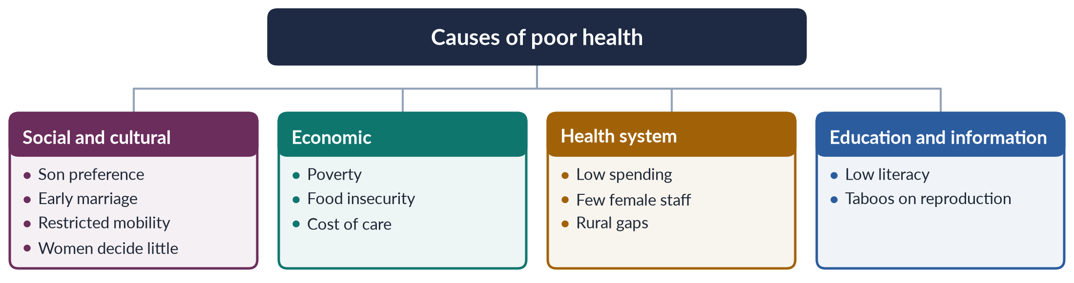
Figure 6 · The causes of women's poor health in Pakistan.

(1) Social and cultural causes
- Son preference — girls may receive less food and later care.
- Early marriage and pressure for early, frequent births, especially of sons.
- Restricted mobility — many women need permission or a male escort to visit a clinic.
- Low decision-making power — husbands and mothers-in-law often decide whether a woman may seek care.
- Preference for female doctors — many women will not see a male doctor, but female doctors are scarce in rural areas.

(2) Economic causes
- Poverty and food insecurity; the cost of transport and medicines.

(3) Health-system causes
- Low public spending — around 1% of GDP for many years.
- Shortage of female health staff, especially in rural areas; many women medical graduates do not practise.
- Urban–rural gaps — basic health units and rural health centres often lack staff, drugs and equipment.

(4) Education and information
- Low female literacy limits knowledge of nutrition, family planning and warning signs in pregnancy.
- Taboos on discussing reproduction and menstruation.

2.4a Nutrition across the life cycle
Malnutrition among women is both a cause and a result of low status. In many households women and girls eat last, after men and boys, and eat less protein. An undernourished girl grows into a short, anaemic woman who is more likely to have a difficult birth and a low-birth-weight baby — who in turn is more likely to be stunted. This intergenerational cycle of malnutrition explains why about 40% of Pakistan's children under five are stunted (NNS 2018). Breaking it requires food security, fortified staples, iron supplements, and above all a change in who eats first.

2.4b Mental health — the hidden burden
Surveys and clinical studies in Pakistan repeatedly find higher rates of depression and anxiety among women than men. The causes are social: domestic violence, forced or early marriage, isolation after marriage into a distant family, pressure to bear sons, poverty and lack of autonomy. Services are scarce — Pakistan has very few psychiatrists for its population — and stigma is high, so women rarely seek help. Integrating mental-health care into primary care and training LHWs to recognise depression are low-cost steps that research in Pakistan has supported.

2.4c Case study: the Lady Health Worker Programme
The National Programme for Family Planning and Primary Health Care, known as the Lady Health Worker Programme, began in 1994 under Benazir Bhutto. Local women with basic education are trained to serve about 1,000 people each in their own communities, visiting homes to provide family-planning advice, antenatal care, immunisation, treatment of minor illnesses and referral. Evaluations have linked the programme to higher contraceptive use, better immunisation and improved maternal and child health. It also created paid jobs for rural women, who travel, earn and organise; after protests, the Supreme Court ordered the regularisation of LHWs in 2012. Its limits: many areas remain uncovered, workers are overburdened, and pay and supplies are sometimes delayed.

2.5 Programmes and policies
- The Lady Health Worker Programme (1994): tens of thousands of LHWs bring basic care, family planning and immunisation to homes — one of Pakistan's most successful programmes for women.
- Community Midwives trained to attend births in villages.
- Health insurance through the Sehat Sahulat Programme (health card) in several provinces.
- BISP cash transfers to women, and nutrition programmes such as Benazir Nashonuma for pregnant women and young children.
- The constitutional duty in Article 35 to protect the mother and child, and Article 37(e) on maternity benefits.
- After the 18th Amendment (2010), health is a provincial subject; provinces run their own programmes.

2.5a Health financing and the Sehat card
Most health spending in Pakistan is out of pocket — families pay for doctors, tests and medicines themselves. For poor women, whose families may not prioritise their care, this cost is a major barrier. The Sehat Sahulat Programme (health card), launched federally in 2015–16 and expanded in several provinces, gives families insurance for hospital treatment, including maternity care. Its benefits for women depend on whether they can reach empanelled hospitals and whether the card is in a name they can use. Critics also note that insurance for hospital care does little to strengthen primary care — where most maternal and child deaths could be prevented.

2.6 Improving women's health within available resources (2017)
The 2017 question asked how health could improve within available economic resources — that is, without large new spending. The answer lies in cost-effective, prevention-first measures:
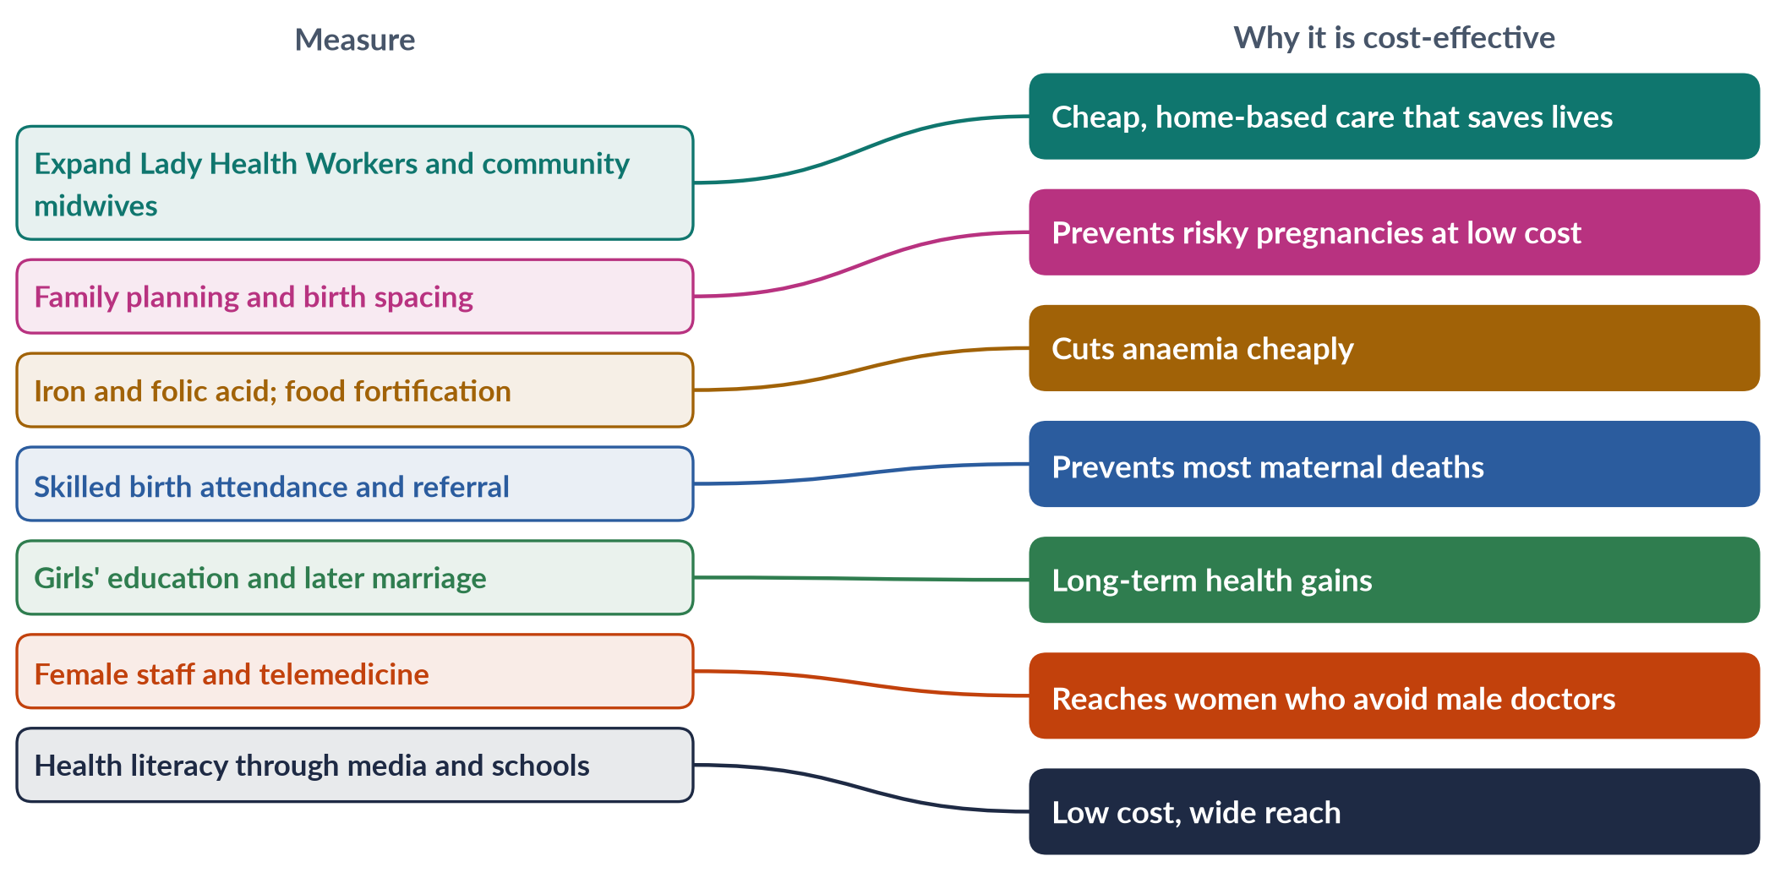
Figure 7 · Cost-effective measures for women's health.
1. Primary care first — strengthen basic health units and LHWs rather than expensive hospitals.
2. Family planning — among the most cost-effective health investments.
3. Nutrition — iron supplements, fortified flour and oil, school and maternal nutrition.
4. Skilled birth attendance and emergency referral (ambulances, blood banks).
5. Female health workforce — incentives for women doctors in rural posts; telemedicine (for example, platforms linking home-based women doctors to rural clinics).
6. Screening for breast and cervical cancer through awareness campaigns.
7. Engage men and mothers-in-law in decisions about women's care.
8. Enforce child-marriage laws — later marriage means safer pregnancies.
9. Better targeting — use BISP data to reach the poorest women.
10. Mental-health services integrated into primary care.
EXAMINER'S EYE · ANSWERING 2017 AND 2023
Describe the status with indicators and dates (table), explain the causes (tree figure), list programmes, and propose measures — for 2017, stress cost-effectiveness; for 2023, which asks how to improve women's "status as a whole", link health to education, employment, law and empowerment. End with a balanced conclusion.

Chapter 3 · Maternal Health and the "Road to Maternal Death"
"An Egyptian doctor, Mahmoud Fathalla, uses the term 'maternity death road' while discussing issues of women's maternal health. Discuss women's health issues in the context of Pakistan's social, cultural and demographic situation" (2024). This chapter explains the idea and applies it to Pakistan.

3.1 Mahmoud Fathalla and the "road to maternal death"
✦ THINKER
Mahmoud Fathalla · Egyptian obstetrician · later president of FIGO, the world federation of gynaecologists
At the Safe Motherhood Conference in Nairobi (1987), which launched the global Safe Motherhood Initiative, Fathalla told the story of "Mrs X" and asked, "Why did Mrs X die?" He showed that a woman's death in childbirth is the end of a long road that begins long before pregnancy — with being born female and poor, being undernourished, married young, denied education and family planning, and finally lacking skilled care when complications strike. Most maternal deaths, he argued, are preventable; they reflect a society's neglect of women.
➜ The question calls this the "maternity death road". Use Fathalla's framing: maternal death is a social failure, not only a medical one.

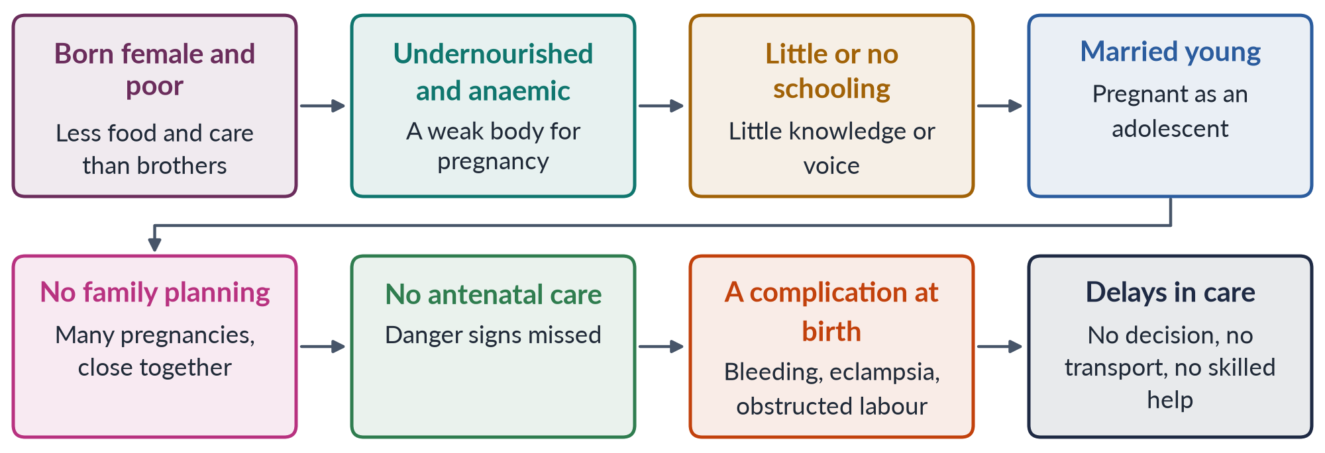
Figure 8 · The road to maternal death (after Fathalla, 1987).

3.2 The three delays
The researchers Sereen Thaddeus and Deborah Maine ("Too Far to Walk", 1994) grouped the final stretch of the road into three delays:
1. Delay in deciding to seek care — the family does not recognise danger, or the woman cannot decide without her husband or mother-in-law; cost and custom hold them back.
2. Delay in reaching care — distance, lack of roads and transport, floods, insecurity.
3. Delay in receiving adequate care — the facility lacks staff, blood, drugs, electricity or surgical capacity.
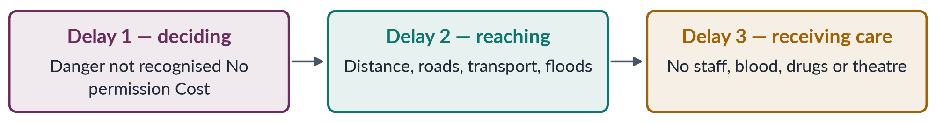
Figure 9 · The three delays that kill mothers.

3.3 Maternal health in Pakistan: the data
✦ DATA
Maternal health in Pakistan · national surveys
• Maternal mortality ratio: 186 per 100,000 live births (Pakistan Maternal Mortality Survey 2019) — far higher in rural areas and in Balochistan.
• Births assisted by a skilled provider: about two-thirds (PDHS 2017–18); many rural births still take place at home with untrained attendants.
• Anaemia among women of reproductive age: about 42% (NNS 2018).
• Total fertility rate: about 3.6 (PDHS 2017–18); contraceptive use about 34%.
• The SDG target 3.1 is a global MMR below 70 by 2030.

The main direct causes of maternal death worldwide — and in Pakistan — are haemorrhage (especially after birth), hypertensive disorders (pre-eclampsia and eclampsia), infection, obstructed labour and unsafe abortion. Almost all can be prevented or treated with skilled care.

3.4 The road in Pakistan's social context
1. Son preference and neglect of girls — girls may be fed and treated less, so they enter adulthood undernourished.
2. Low female literacy — about 53% (Census 2023), far lower in rural areas; uneducated mothers know less about danger signs and family planning.
3. Poverty — the cost of transport, medicines and private care delays treatment.
4. Low decision-making power — decisions about antenatal care and hospital delivery are often taken by husbands and mothers-in-law.

3.5 The road in Pakistan's cultural context
1. Early marriage — many girls marry before 18; adolescent mothers face higher risks. Only Sindh (2013) and Islamabad (2025) set the minimum age at 18; Punjab's Assembly passed a child-marriage bill in 2026; elsewhere the federal age for girls remained 16.
2. Purdah and mobility — women may need a male escort to travel to a clinic.
3. Preference for female health workers — many women refuse male doctors; female staff are scarce in rural posts.
4. Home births and traditional birth attendants (dais) are culturally preferred in many areas.
5. Taboos on discussing pregnancy, family planning and menstruation.
6. Pressure to have sons leads to repeated, closely spaced pregnancies.

3.6 The road in Pakistan's demographic context
1. High population growth — the Census 2023 counted about 241 million people, growing at about 2.55% a year; high fertility means many pregnancies and many risks.
2. A young population — many adolescent girls reaching marriage age each year.
3. Rural majority — most people still live in rural areas, where services are thinnest.
4. Regional inequality — Balochistan and parts of Sindh and Khyber Pakhtunkhwa have the worst indicators.
5. Disasters — the 2022 floods left about 650,000 pregnant women in affected areas (UNFPA).
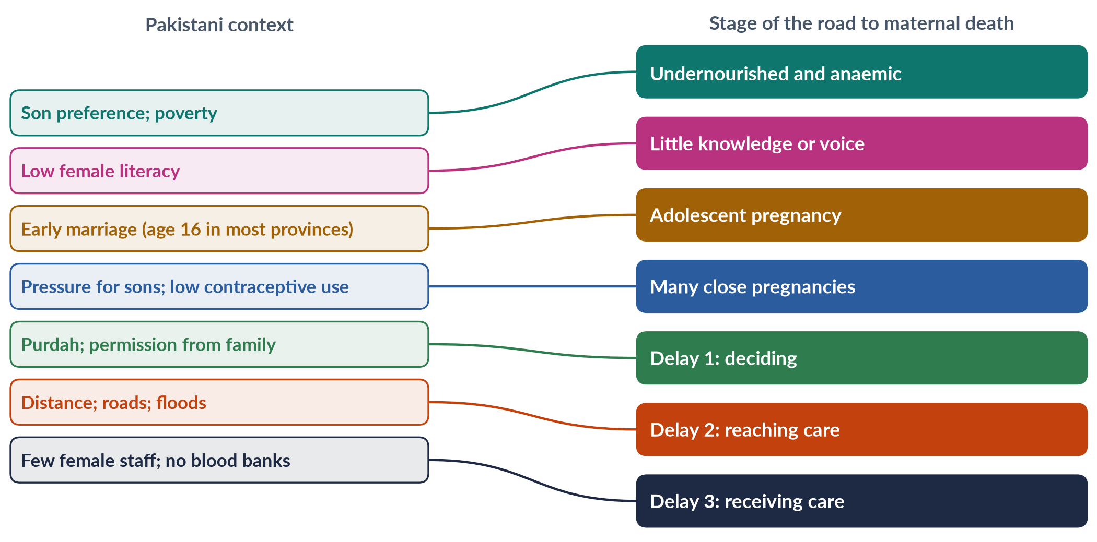
Figure 10 · Pakistan's context and the stage of the road it affects.

3.6a A Pakistani "Mrs X"
Imagine a woman in a village in Balochistan. She was born the fourth daughter in a poor family and fed after her brothers. She left school after class three because the nearest girls' middle school was ten kilometres away. At fifteen she was married to a cousin. She became pregnant within a year and had five children in eight years, because her husband and mother-in-law wanted sons and no one offered her family planning. She was anaemic in every pregnancy and never saw a doctor. When she began to bleed heavily after her sixth delivery at home, the family waited for her husband to return from the fields to decide what to do. The nearest hospital with a blood bank was four hours away on a broken road. She died on the way.
Every stage of her story — son preference, distance from school, early marriage, repeated pregnancy, anaemia, the decision delay, the transport delay, the lack of blood — is a point where policy could have saved her. This is exactly Fathalla's argument: maternal death is the end of a road built by society.

3.6b Why Fathalla called it a social problem
Fathalla insisted that maternal deaths are not "natural" or "fate". Most are caused by complications that medicine has known how to treat for decades. Women die because societies do not give them education, nutrition, family planning, skilled care and a voice. In his words at the time, women were dying "not because of diseases we cannot treat" but because societies had yet to decide that their lives were worth saving. This framing shifted global health policy from purely medical solutions to women's rights and empowerment — the approach later adopted by the ICPD in Cairo (1994) and the Beijing Platform (1995).

3.6c Family planning — the neglected stage
Family planning prevents the most dangerous pregnancies: those that come too early (in adolescence), too late, too often and too close together. Yet contraceptive use in Pakistan has stayed around a third of married women for years, and many women who want to delay or stop childbearing lack access — an unmet need that surveys put at about one in six married women. Barriers include distance, cost, fear of side effects, religious misconceptions, and husbands' or mothers-in-law's opposition. Lady Health Workers, pharmacies, community midwives and religious leaders who explain that Islam permits birth spacing have all been used to widen access. Pakistan's rapid population growth — about 2.55% a year (Census 2023) — makes this both a women's-health and a national development issue.

3.7 Closing the road — what works
1. Delay marriage — enforce and extend 18-year minimum age laws; keep girls in school.
2. Nutrition — iron and folic acid, food fortification, BISP-linked nutrition support.
3. Family planning — make contraception available through LHWs and pharmacies; involve men.
4. Antenatal care — at least four visits (WHO now recommends eight contacts).
5. Skilled birth attendance — community midwives and LHWs; incentives for facility births.
6. Emergency obstetric care — 24-hour facilities with blood banks and surgery within reach; ambulances (such as provincial Rescue 1122 services).
7. Female health workforce — rural posts for women doctors; telemedicine.
8. Community awareness — teach families the danger signs; engage mothers-in-law, husbands and religious leaders.
9. Data — record every maternal death and learn from it (maternal death reviews).
EXAMINER'S EYE · THE MODEL STRUCTURE FOR 2024
1. Introduction: Fathalla, Nairobi 1987, "Why did Mrs X die?"; the road as a social failure; Pakistan's MMR 186. 2. The road explained (flow figure) and the three delays. 3. Social context (son preference, literacy, poverty, decision-making). 4. Cultural context (early marriage, purdah, female staff, home births, taboos). 5. Demographic context (241 million, 2.55%, young, rural, regional gaps, floods). 6. Other women's health issues along the road (anaemia, cancers, mental health, violence). 7. Programmes (LHWs, midwives, Sehat card, BISP). 8. Way forward. 9. Conclusion: close the road at every stage. Draw the mapping figure.

Chapter 4 · Women's Education in Pakistan
Education is a syllabus line that has never been a full question — the clearest blind spot in the paper (a likely question in Part Three). A 2019 MCQ quoted a female literacy rate of 48%; the Census 2023 put it at about 53%.

4.1 Why girls' education matters
Girls' education is often called the single best investment in development. An educated woman:
- marries later and has fewer, healthier children;
- is more likely to seek antenatal care and immunise her children;
- earns more and has more say in household decisions;
- is better able to know and claim her legal rights;
- passes education on to her children, especially daughters.
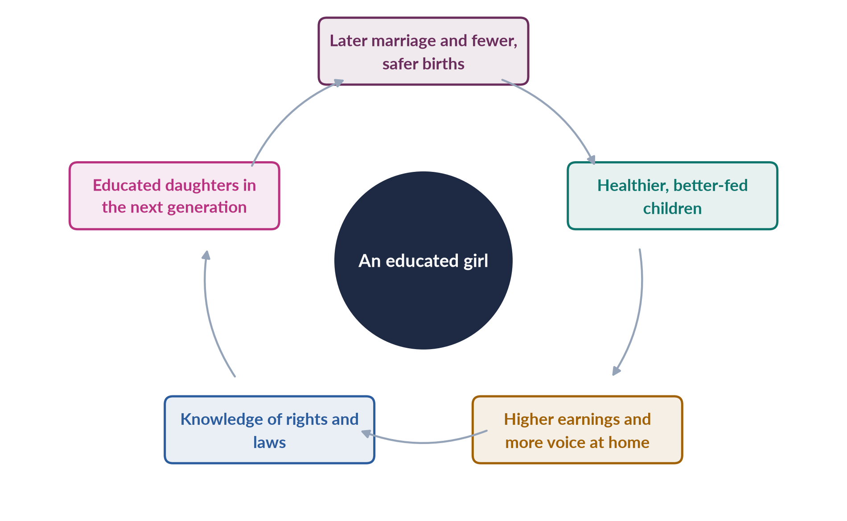
Figure 11 · The virtuous cycle of girls' education.

4.2 The constitutional duty
✦ LAW & POLICY
Article 25A, Constitution of Pakistan · added by the 18th Amendment (2010)
"The State shall provide free and compulsory education to all children of the age of five to sixteen years in such manner as may be determined by law."
➜ Provinces and Islamabad passed compulsory-education laws after 2010; enforcement remains weak.

4.3 The current status
Table 4 · Women's education in Pakistan — key figures.
Indicator | Value | Source
Literacy (age 10+) | about 68% men, 53% women; 60.65% overall | Census 2023
Out-of-school children (5–16) | more than 25 million, most of them girls | Pakistan Education Statistics
Educational attainment rank | 130th of 145 | Global Gender Gap Report 2026
Female literacy used by the WEF | about 48.5% | Global Gender Gap Report 2025

Patterns behind the averages:
1. Rural–urban gap — rural women's literacy is far below urban women's.
2. Provincial gap — Punjab and Islamabad lead; Balochistan and parts of Khyber Pakhtunkhwa and Sindh lag.
3. Dropout — girls' enrolment falls sharply after primary school, when schools are farther away and puberty brings restrictions.
4. Higher education — women now form a large share (close to half) of university students, and a majority in some fields such as medicine; but many women graduates never enter paid work.
5. Quality — learning levels are low for all children; girls' schools often lack teachers and toilets.

4.3a The pattern across provinces
National averages hide very large differences. In Punjab and Islamabad, girls' enrolment has risen sharply and gender gaps at primary level have narrowed. In Sindh, rural girls lag far behind urban girls. In Khyber Pakhtunkhwa, especially the former tribal districts, conflict and conservative norms kept many girls out of school, though enrolment has improved since 2010. Balochistan has the lowest female literacy and the largest share of girls out of school, because of vast distances, poverty and a severe shortage of girls' schools and female teachers. Any answer on women's education should note these regional contrasts.

4.4 Why girls are out of school — the causes
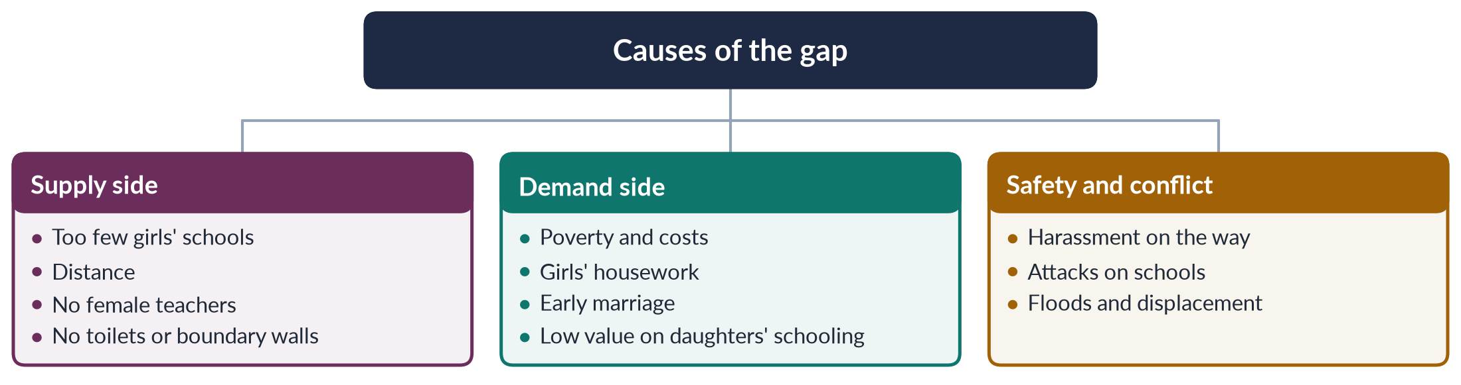
Figure 12 · Causes of the gender gap in education.

(1) Supply-side causes
- Too few girls' schools, especially at middle and secondary level; many villages have a primary school only.
- Distance — parents will not let daughters walk far, particularly after puberty.
- Shortage of female teachers in rural areas.
- Poor facilities — no toilets, boundary walls or drinking water.

(2) Demand-side causes
- Poverty and costs — uniforms, books, transport, and lost help at home.
- Girls' domestic work — caring for siblings, fetching water, housework.
- Early marriage — girls withdrawn to be married.
- Norms — the belief that a daughter "belongs to another household" and that her education brings no return to her parents.

(3) Safety, conflict and disasters
- Harassment on the way to school.
- Militant attacks — in Swat and the former tribal areas, militants destroyed hundreds of schools, many for girls; Malala Yousafzai was shot on 9 October 2012 for speaking up for girls' education, and won the Nobel Peace Prize in 2014.
- Floods — the 2022 floods destroyed or damaged thousands of schools.

4.4a Higher education and the "doctor brides" paradox
Women now make up a large share of university students, and in medical colleges women often outnumber men. Yet many women graduates, including large numbers of doctors, never practise or stop after marriage. Families sometimes value a medical degree as a marker of status for marriage rather than as the start of a career — the so-called "doctor brides" phenomenon. The result is a waste of public investment and a shortage of female doctors in rural areas where women need them most. Remedies discussed include flexible hours, telemedicine (which lets women doctors consult from home), childcare at hospitals, and incentives for rural service.

4.4b Education in conflict: the Swat story
Between 2007 and 2009, militants in the Swat valley banned girls' education and destroyed many schools. A young girl, Malala Yousafzai, wrote an anonymous diary for the BBC Urdu service in 2009 describing life under the ban. On 9 October 2012 she was shot on her school bus. She survived, spoke at the United Nations on her sixteenth birthday (12 July 2013) and in 2014 became the youngest-ever Nobel Peace Prize laureate. Her case made girls' education in Pakistan a global cause — and showed that the barriers to girls' schooling include violence as well as poverty and custom.

4.4c Religious schools and girls
Many girls study in madrassas (religious schools), which are often free and close to home and are acceptable to conservative families. They provide literacy and religious knowledge but, in many cases, limited teaching in mathematics, science and languages. Proposals to register and mainstream madrassas and add modern subjects aim to widen these girls' opportunities.

4.5 Programmes that work
- Stipends for girls — Punjab's female school stipend programme (from 2004) raised girls' enrolment in secondary school.
- BISP Waseela-e-Taleem / conditional cash transfers linked to children's school attendance.
- Community and home schools in villages without girls' schools.
- Female teacher recruitment and incentives for rural posts.
- Missing facilities programmes (toilets, walls, water).
- Non-formal education and adult literacy centres for women.
- Scholarships for women in higher education.

4.5a Adult women's literacy
Millions of adult women in Pakistan never went to school. Adult literacy and non-formal education programmes — run by provincial literacy departments, the National Commission for Human Development and NGOs — teach reading, writing and basic numeracy, often linked to skills such as sewing or financial literacy. Mobile-phone-based literacy courses have been tried to reach women who cannot attend classes. Adult literacy helps women read medicine labels, use mobile banking, understand documents and support their children's schooling — but programmes have usually been small and under-funded compared with the scale of need.

4.6 The way forward
1. Enforce Article 25A — make compulsory education real, with accountability.
2. Build middle and secondary schools for girls within walking distance, or provide safe transport.
3. Recruit and train female teachers locally.
4. Expand stipends and cash transfers tied to girls' attendance.
5. Enforce child-marriage laws and raise the minimum age to 18 everywhere.
6. Protect schools in conflict and disaster areas; rebuild quickly after floods.
7. Change norms — involve parents, religious leaders and media; show role models.
8. Link education to work — skills, digital literacy and safe jobs so that education pays off for women.
9. Increase spending on education, which has long stayed around 2% of GDP.
PAKISTAN ANGLE · A LIKELY QUESTION
"Discuss the status of women's education in Pakistan. What are the causes of the gender gap, and how can it be closed?" Use this chapter's structure: why it matters (cycle figure) → Article 25A → status (table) → causes (tree) → programmes → way forward.

Chapter 5 · Women and Employment: Participation, Barriers and the Double Burden
"Women's participation in the labour force has increased recently, yet women continue to perform their reproductive roles. Discuss the challenges encountered by women as a result of paid employment worldwide, with special reference to Pakistan" (2019). MCQs asked about the glass ceiling (2024), the sticky floor (2026) and comparable worth (2023).

5.1 Women's work in Pakistan — the data
✦ DATA
Women in Pakistan's labour force · Labour Force Survey 2024–25 (PBS)
• Female labour-force participation: 24.4% (up from about 21.4% in 2020–21).
• By province: Punjab 33.8%, Khyber Pakhtunkhwa 21.1%, Sindh 20.5%, Balochistan 14.5%.
• Most employed women work in agriculture or in informal work — much of it unpaid family work or home-based piece work.
• Pakistan ranked 144th of 145 on economic participation in the Global Gender Gap Report 2026.

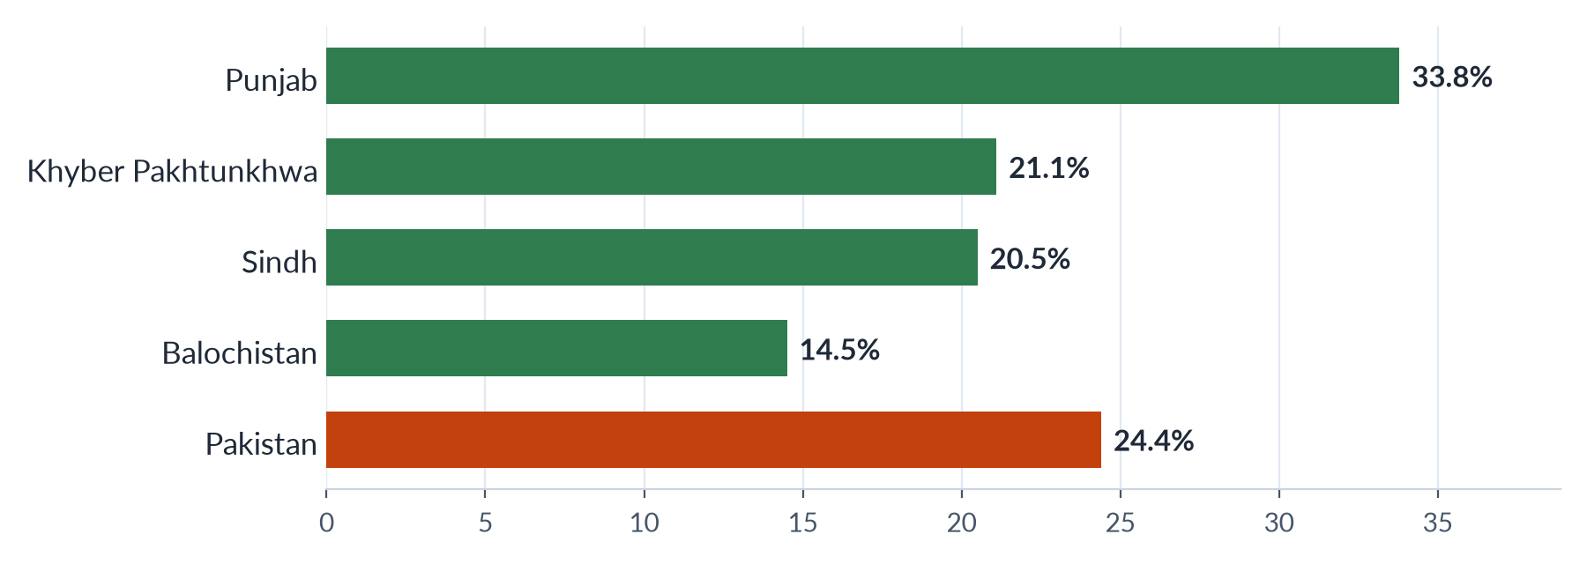
Figure 13 · Female labour-force participation by province, 2024–25 (%).

5.2 Where women work
1. Agriculture — sowing, weeding, cotton picking, harvesting and livestock care; often unpaid, as family helpers.
2. Home-based work — stitching, embroidery, bangle-making, packing, often for piece rates through middlemen.
3. Domestic work — cooking and cleaning in other people's homes, without contracts.
4. Services — teaching and health (teachers, nurses, Lady Health Workers).
5. Manufacturing — garments, textiles, pharmaceuticals, food processing.
6. Professions and new sectors — doctors, lawyers, bankers, IT, freelancing; small but growing.

5.3 The double burden: paid work plus reproductive roles
✦ DEFINITION
Reproductive roles · the 2019 question's key phrase
The unpaid work of bearing and raising children and maintaining the household — cooking, cleaning, caring for the sick and elderly. Caroline Moser calls this women's reproductive role, alongside their productive (paid) and community roles (the triple role).

When women take paid jobs, their reproductive work rarely falls. They work a "second shift" at home (Arlie Hochschild, 1989). The result is the double burden: long hours, fatigue, stress and little rest or leisure.

5.4 Challenges of paid employment — worldwide
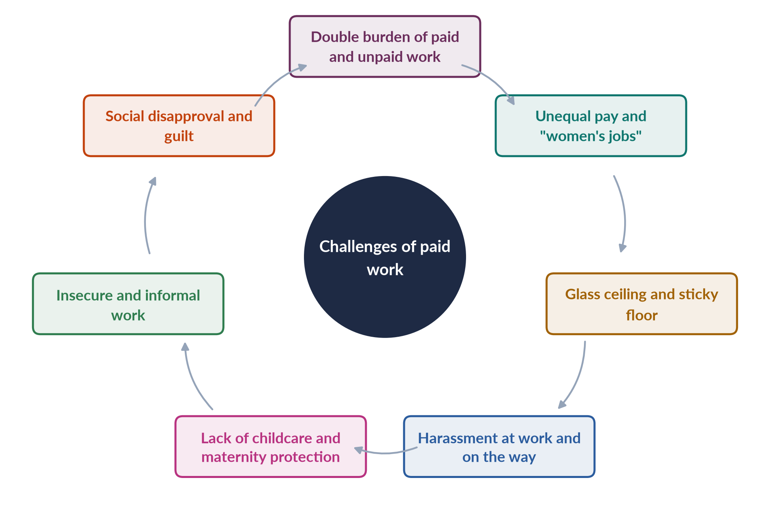
Figure 14 · The challenges women face in paid employment.
1. The double burden — paid work plus unpaid care; women globally do about three times as much unpaid care work as men (ILO, 2018).
2. Unequal pay — the gender pay gap; women's jobs are valued less. Comparable worth means equal pay for work of equal value — its absence leads to "sex segregation and less pay for women's work" (MCQ 2023).
3. Occupational segregation — women crowded into teaching, nursing, garments and care.
4. The glass ceiling — invisible barriers to the top (MCQ 2024); few women managers or board members.
5. The sticky floor — women stuck in low-wage, low-mobility jobs (MCQ 2026).
6. The motherhood penalty — lower pay and promotion after having children.
7. Harassment — at work and while commuting.
8. Lack of childcare and maternity protection.
9. Insecure, informal work — no contracts, pensions or social security.
10. Social disapproval — criticism for "neglecting" family; guilt; conflict at home.

5.5 The challenges in Pakistan

(1) Mobility and safety
Unsafe, crowded public transport and harassment on the street keep many women out of work. Families often forbid work far from home. Some cities have introduced women-only buses and ride-hailing, with mixed success.

(2) Social norms
The ideal of the male breadwinner and family honour discourage women's work outside the home, especially in mixed workplaces. Many families accept teaching and medicine but not other jobs.

(3) The double burden in joint families
Working women in joint families may still be expected to do most cooking and care, and to defer to in-laws.

(4) Pay and informality
Most working women are in informal jobs without contracts. The ILO has reported one of the widest gender pay gaps in the world in Pakistan. Home-based workers earn very low piece rates.

(5) Harassment at work
The Protection against Harassment of Women at the Workplace Act was passed in 2010 (MCQs 2016, 2018, 2019, 2024) and amended in 2022 to widen the definitions of "workplace" and "employee". It requires inquiry committees and created an ombudsperson; enforcement is uneven, especially in the private and informal sectors.

(6) Childcare and maternity
Few workplaces have day-care centres. Laws have improved: the federal Maternity and Paternity Leave Act 2020 (Islamabad) extended paid maternity leave and introduced paternity leave; Sindh passed a Maternity Benefits Act in 2018. Coverage in the private and informal sectors is weak.

(7) The "missing" educated women
Many educated women — including large numbers of medical graduates — do not enter or leave the workforce after marriage.

(8) Quotas and public jobs
A 10% quota for women in federal services was introduced in the 2000s (MCQ 2018 key: under the PML-Q government, 2002); provinces have their own quotas. Many quota posts go unfilled.

5.5a Women in agriculture
Agriculture employs most working women in Pakistan. Women sow, transplant rice, weed, pick cotton, harvest wheat, cut fodder and care for livestock, as well as processing crops at home. Much of this work is unpaid family labour or paid at very low seasonal rates, often to the husband rather than the woman. Women rarely own land or control its income, and seldom receive credit, extension advice or new technology. Cotton pickers work long hours in heat, exposed to pesticides. Recognising women as farmers — through land rights, extension services for women, and minimum wages for farm labour — would raise both their status and agricultural output.

5.5b Home-based workers
Millions of Pakistani women work at home — stitching garments, embroidering, making bangles, rolling incense sticks, packing goods — for piece rates paid through middlemen. Because they work at home, their work is often counted as "housework" and escapes labour laws. They have no contracts, minimum wage, social security or pensions, and they carry the costs of electricity and equipment. The Sindh Home-Based Workers Act 2018 was the first law to recognise them as workers with rights to minimum wages and social security; other provinces have moved more slowly. Organisations such as the Home-Based Women Workers Federation have campaigned for these rights.

5.5c Women in the formal sector and professions
A small but growing number of Pakistani women work in the formal economy — in banks, telecoms, pharmaceuticals, universities, the civil service, the armed forces, the police and the courts. Women have become fighter pilots, generals, judges of the Supreme Court (the first woman judge of the Supreme Court, Justice Ayesha Malik, took oath in 2022) and chief executives. These role models matter, but they remain exceptions: women hold a very small share of managerial and senior posts, and the professions they enter are often segregated.

5.6 Benefits of paid work — the other side
Paid work brings women income, independence, confidence, social networks and a stronger voice at home. Studies of garment workers in Bangladesh (Naila Kabeer, 2000) found that wage work delayed marriage and increased women's bargaining power. The challenge is to make work decent, not to keep women out of it.

5.7 Laws and programmes
Table 5 · Laws and programmes on women's work in Pakistan.
Year | Law or programme | Effect
2000s | 10% quota in federal services | Reserved posts for women
2010 | Protection against Harassment of Women at the Workplace Act (amended 2022) | Inquiry committees; ombudsperson
2018 | Sindh Home-Based Workers Act | First recognition of home-based workers
2018 | Sindh Maternity Benefits Act | Maternity leave and benefits
2019 | Punjab Domestic Workers Act | Rights for domestic workers
2020 | Maternity and Paternity Leave Act (Islamabad) | Longer paid maternity leave; paternity leave
2008 onward | BISP cash to women | Income in women's own names

5.8 The way forward
1. Safe transport and enforcement of the harassment law on the street and at work.
2. Childcare — workplace day-care, public crèches, school hours that fit working hours.
3. Share care — paternity leave; campaigns for men's share of housework.
4. Equal pay for work of equal value; minimum wages enforced for women.
5. Protect informal workers — home-based and domestic workers' laws in all provinces; social security.
6. Skills and digital work — vocational and digital training; safe online work.
7. Women in management — mentoring, targets for boards and senior posts.
8. Count unpaid work — time-use surveys; recognise care in policy (SDG target 5.4).
EXAMINER'S EYE · THE MODEL STRUCTURE FOR 2019
1. Introduction: participation rising (24.4%), yet reproductive roles remain — the double burden. 2. Reproductive roles and the triple role (Moser). 3. Worldwide challenges (ten, with the MCQ terms glass ceiling, sticky floor, comparable worth). 4. Pakistan's challenges (mobility, norms, joint families, pay and informality, harassment, childcare). 5. The benefits of paid work. 6. Laws and programmes (table). 7. Way forward. 8. Conclusion: make work decent and share care. Draw the cycle figure.

Chapter 6 · Women and the Law (1): The Constitution and Family Law
MCQs repeatedly ask for the Muslim Family Laws Ordinance (1961; MCQs 2016, 2018) and the minimum marriage age for girls under federal law (16; MCQs 2016, 2019). This chapter covers women's constitutional rights and the family laws that govern marriage, divorce, maintenance, custody and inheritance.

6.1 Women in the Constitution of 1973
Pakistan's Constitution gives women equal citizenship and allows special measures in their favour.
Table 6 · Women's rights in the Constitution of Pakistan.
Article | Content
8 | Laws inconsistent with fundamental rights are void
9, 14 | Security of person; dignity of man and privacy of home
11 | Slavery and forced labour prohibited; trafficking in human beings prohibited
25 | Equality before law; no discrimination on the basis of sex; special provision for women and children allowed
25A | Free and compulsory education, ages 5–16 (2010)
26, 27 | No discrimination in public places or public service on the basis of sex
32 | Special representation of women in local government
34 | Full participation of women in all spheres of national life
35 | Protection of marriage, family, mother and child
37(e) | Just and humane conditions of work; maternity benefits
51, 59, 106 | Reserved seats for women in the National Assembly (60), Senate and provincial assemblies

IN SIMPLE WORDS
Fundamental rights (Articles 8–28) can be enforced in court. Principles of Policy (Articles 29–40, including 32, 34, 35 and 37) are goals the state should pursue, but citizens cannot sue directly to enforce them.

6.2 Family law — the sources
Family matters for Muslims in Pakistan are governed by Muslim personal law as modified by statute:
- the Muslim Personal Law (Shariat) Application Act 1937 (and the West Punjab Act of 1948, which extended Islamic inheritance to agricultural land);
- the Dissolution of Muslim Marriages Act 1939 — grounds on which a wife can seek divorce through the court;
- the Muslim Family Laws Ordinance 1961 (MFLO);
- the Family Courts Act 1964 — special courts for family cases;
- the Child Marriage Restraint Act 1929 and newer provincial laws;
- the Guardians and Wards Act 1890 — custody of children;
- the Dowry and Bridal Gifts (Restriction) Act 1976.
Non-Muslim communities have their own personal laws — for example, the Hindu Marriage Act 2017 (federal) and the Sindh Hindu Marriage Act 2016, which gave Hindu marriages legal registration for the first time.

6.3 The Muslim Family Laws Ordinance 1961
✦ LAW & POLICY
Muslim Family Laws Ordinance 1961 · promulgated by Ayub Khan
Born of women's protests after PM Bogra's second marriage (1955) and the Rashid Commission (report 1956):
• Registration of marriages (nikah) with the Union Council.
• Polygamy: a man needs the written permission of an Arbitration Council, after the existing wife's views are heard, to take another wife.
• Divorce (talaq): the husband must give notice to the Union Council chairman and the wife; the divorce takes effect only after 90 days, allowing reconciliation.
• Maintenance: a wife can apply for maintenance.
• Inheritance: children of a predeceased son or daughter (orphaned grandchildren) inherit their parent's share.
• Marriage age: it amended the 1929 Act to raise the minimum age for girls to 16 (boys 18).
➜ The MFLO remains the core of women's family-law rights; the Council of Islamic Ideology and some scholars have criticised parts of it.

6.4 Divorce, *khula* and maintenance
- Judicial divorce (1939 Act): grounds include the husband's absence, failure to maintain for two years, cruelty, and taking another wife without equitable treatment.
- Khula: a wife's right to seek divorce through the court, usually by returning the dower. The Supreme Court recognised it in Khurshid Bibi v. Muhammad Amin (1967). Family courts now grant khula widely; amendments to the Family Courts Act (2002, 2015) aimed at faster decisions.
- Haq mehr (dower): the husband's obligation to the wife; registration on the nikah-nama helps enforcement.
- Maintenance of wife and children; courts can order interim maintenance.
- The nikah-nama: the marriage contract includes a clause by which the husband can delegate the right of divorce (talaq-e-tafweez) to the wife — rarely used, often crossed out.

6.5 Child marriage
Table 7 · Minimum marriage age for girls in Pakistan's laws.
Law | Girls' age | Note
Child Marriage Restraint Act 1929, as amended by the MFLO 1961 | 16 | Federal law; applied in most provinces (MCQs 2016, 2019)
Sindh Child Marriages Restraint Act 2013 | 18 | First province to set 18 for both sexes
ICT Child Marriage Restraint Act 2025 | 18 | Assent 30 May 2025; Islamabad; opposed by the Council of Islamic Ideology
Punjab | — | The Punjab Assembly passed a child-marriage restriction bill in April 2026

The Federal Shariat Court in 2021 held that fixing a minimum marriage age is not against Islam — a ruling reformers cite.

6.6 Inheritance and property
- Islamic law gives daughters a share (half a son's share), wives and mothers fixed shares.
- In practice, many women are denied their shares by custom, pressure to "gift" them to brothers, or lack of documents. Customs such as haq bakhshwana (making a woman waive her share) persist.
- The Prevention of Anti-Women Practices Act 2011 made depriving a woman of inheritance by deceitful means a crime.
- The Enforcement of Women's Property Rights Act 2020 (Islamabad) lets women complain to an ombudsperson to get their property quickly; provinces have similar mechanisms.
- Women own a very small share of land in Pakistan — a key cause of their economic weakness.

6.7 Custody and guardianship
Under the Guardians and Wards Act 1890, courts decide custody on the welfare of the child. Traditionally mothers have custody of young children (hizanat) and fathers remain natural guardians. Courts increasingly place the child's welfare above rigid rules.

6.7a Landmark cases on women's family rights
- Khurshid Bibi v. Muhammad Amin (Supreme Court, 1967) — recognised a wife's right to khula, divorce through the court, even without the husband's consent.
- The Saima Waheed case — the Lahore High Court (1997) and then the Supreme Court (2004) held that an adult Muslim woman may marry of her own free will without her guardian's (wali's) consent. The case confirmed women's right to choose their spouse.
- The Federal Shariat Court (2021) held that fixing a minimum age of marriage is not against Islam.
- Superior courts have repeatedly held that a woman's inheritance cannot be taken away by custom or by pressured "gifts" to brothers.
These judgments show that the courts, not only legislators, have extended women's family rights — often by reading Islamic principles in a woman-friendly way.

6.7b Dowry and marriage expenses
Dowry (jahez) — goods and money given by the bride's family — places a heavy burden on poor families and is one reason daughters are seen as a cost. The Dowry and Bridal Gifts (Restriction) Act 1976 limits the value of dowry and gifts, but it is almost never enforced. Disputes over dowry can lead to violence against wives. Some provinces and districts have tried to ban dowry displays and lavish wedding meals; campaigns by religious scholars stress that Islam requires the husband to pay mehr, not the bride's family to pay dowry.

6.8 Assessment
BALANCED VIEW · HOW FAR DOES FAMILY LAW PROTECT WOMEN?
• Gains: registration of marriage, notice of divorce, limits on polygamy, khula, maintenance, family courts, inheritance for orphaned grandchildren, rising marriage ages in Sindh and Islamabad.
• Gaps: weak registration in rural areas; polygamy often without permission; the minimum age for girls still 16 in some provinces; inheritance widely denied; slow courts; legal costs; women's lack of knowledge of their rights.
➜ Family law has moved forward in steps, often after women's campaigns, but enforcement and awareness remain the main problems.

Chapter 7 · Women and the Law (2): Protective Laws, Human Rights and the Enforcement Gap
This chapter covers criminal and protective laws for women, the machinery for human rights, and why laws on paper often fail in practice. It answers the 2020 question — a statement about "a system which fully guarantees human rights… and provides operative safeguards and expeditious remedy against any violation" — and supplies MCQ facts: the 2006 Act and the NCSW (both under Musharraf), the 2002 women's policy, the 2010 harassment law.

7.1 From the Hudood Ordinances to the Women's Protection Act
- The Hudood Ordinances (1979) made zina (including rape) an offence under a new Islamic code. A woman who reported rape but could not prove it risked being charged with zina herself; thousands of women were jailed.
- After years of campaigning by women's groups and a report of the National Commission on the Status of Women, the Protection of Women (Criminal Laws Amendment) Act 2006, passed under Pervez Musharraf (MCQ 2016), moved rape back into the Pakistan Penal Code, removed the risk of a rape complainant being charged with zina, and made zina cases harder to bring maliciously.

7.2 The protective laws
Table 8 · Pakistan's main protective laws for women.
Year | Law | Key provisions
2004 | Criminal Law (Amendment) Act | First law naming offences "in the name of honour"
2006 | Protection of Women (Criminal Laws Amendment) Act | Rape moved to the Penal Code
2010 | Protection against Harassment of Women at the Workplace Act (amended 2022) | Inquiry committees; ombudsperson; code of conduct
2010 | Criminal Law (Amendment) Act (s. 509 PPC) | Sexual harassment in public places made an offence
2011 | Acid Control and Acid Crime Prevention Act | Severe punishment for acid attacks
2011 | Prevention of Anti-Women Practices Act | Criminalises forced marriage, marriage to settle disputes (vani, swara), "marriage" to the Qur'an, and deprivation of inheritance
2013–2025 | Domestic violence laws: Sindh (2013), Balochistan (2014), Punjab (2016), Khyber Pakhtunkhwa (2021), Islamabad (2025) | Protection orders; shelters; the Punjab Act created violence-against-women centres
2016 | Criminal Law (Amendment) (Offences in the Name or Pretext of Honour) Act | Mandatory life imprisonment even if the family forgives
2016 | Criminal Law (Amendment) (Offences relating to Rape) Act | DNA testing; stronger rape provisions
2016 | Prevention of Electronic Crimes Act | Online harassment and image-based abuse
2018 | Transgender Persons (Protection of Rights) Act | Rights of transgender persons (parts struck down by the FSC in 2023; appeal pending)
2020 | Enforcement of Women's Property Rights Act (Islamabad) | Fast remedy for denied property
2021 | Anti-Rape (Investigation and Trial) Act | Special courts; sexual-offences investigation units; anti-rape crisis cells
2025 | ICT Child Marriage Restraint Act | Minimum age 18 in Islamabad

7.3 The machinery for women's rights and human rights
Table 9 · Institutions that protect women's rights.
Institution | Year | Role
National Commission on the Status of Women (NCSW) | 2000 | Reviews laws and policies; statutory autonomy strengthened by the NCSW Act 2012 (set up under Musharraf — MCQ 2016)
National Policy for Development and Empowerment of Women | 2002 | First national women's policy (MCQ 2018)
Provincial commissions on the status of women | 2010s | Provincial counterparts after the 18th Amendment
National Commission for Human Rights (NCHR) | 2012 | Independent human-rights institution under the NCHR Act 2012
Ministry of Human Rights | 2015 | Federal ministry for human-rights policy
Federal and provincial ombudspersons for harassment | 2010 onward | Complaints under the harassment law
Punjab Women Protection Authority; violence-against-women centres | 2017 onward | One-stop help for survivors (first centre in Multan)
Women's police stations and gender units | 1994 onward | Women-friendly policing
Family courts | 1964 | Family disputes

7.4 The 2020 statement: a system that guarantees human rights
The statement sets out three requirements for a democratic welfare state:
1. A system that fully guarantees human rights (laws and institutions);
2. An environment in which people can use and enjoy those rights in practice;
3. Operative safeguards and speedy remedies when rights are violated.
Its wording closely follows the preamble of Pakistan's National Commission for Human Rights Act 2012. Applied to women, each requirement can be tested.
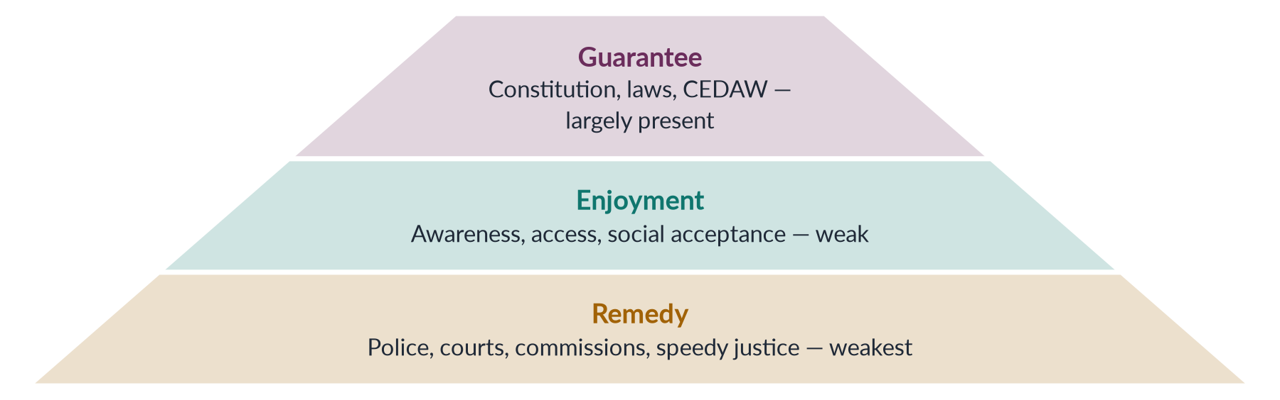
Figure 15 · Three levels of a human-rights system, tested for Pakistani women.

(1) Guarantees — largely in place
The Constitution (Articles 8–28, 25, 34, 35), international treaties (CEDAW 1996; the ICCPR and ICESCR, ratified in 2010 and 2008) and the protective laws above provide a broad legal framework.

(2) Enjoyment — weak
Many women do not know their rights; poverty, illiteracy, restricted mobility and social pressure stop them from using them. Custom often overrides law — as in the denial of inheritance and forced marriages.

(3) Remedies — weakest
- Police may refuse to register complaints or pressure women to "settle".
- Courts are slow and expensive; cases take years; conviction rates for rape and violence are low.
- Compromise and "forgiveness" in the family or the jirga replace justice.
- Commissions lack powers and funds; some posts stay vacant for long periods.

7.4a Case study: honour killing and the "forgiveness" loophole
Under the Qisas and Diyat laws (1990, made permanent in 1997), murder became an offence against the victim's heirs, who could forgive the killer or accept compensation. In honour killings, the killer is usually a family member — so the family could "forgive" him and he walked free. The murder of social-media celebrity Qandeel Baloch by her brother in July 2016 caused national outrage. In October 2016 Parliament passed the anti-honour-killing law, making life imprisonment mandatory even when the family forgives. Human-rights groups continue to record hundreds of honour killings a year, and some cases are still disguised as other crimes or settled out of court. The case shows both the power of law reform and the limits of law alone.

7.4b Women's human rights and Pakistan's international obligations
Women's rights are part of human rights. Pakistan has joined the main UN treaties: CEDAW (1996), the Convention on the Rights of the Child (1990), the International Covenant on Economic, Social and Cultural Rights (2008), the International Covenant on Civil and Political Rights (2010) and the Convention against Torture (2010). It reports regularly to UN treaty bodies and undergoes the Universal Periodic Review at the UN Human Rights Council. Trade preferences under the EU's GSP+ scheme (from 2014) depend on implementing 27 conventions, including CEDAW. These commitments give women's groups international standards to cite — but, as the gender-gap ranking shows, commitments abroad have outrun enforcement at home.

7.5 Why the enforcement gap exists
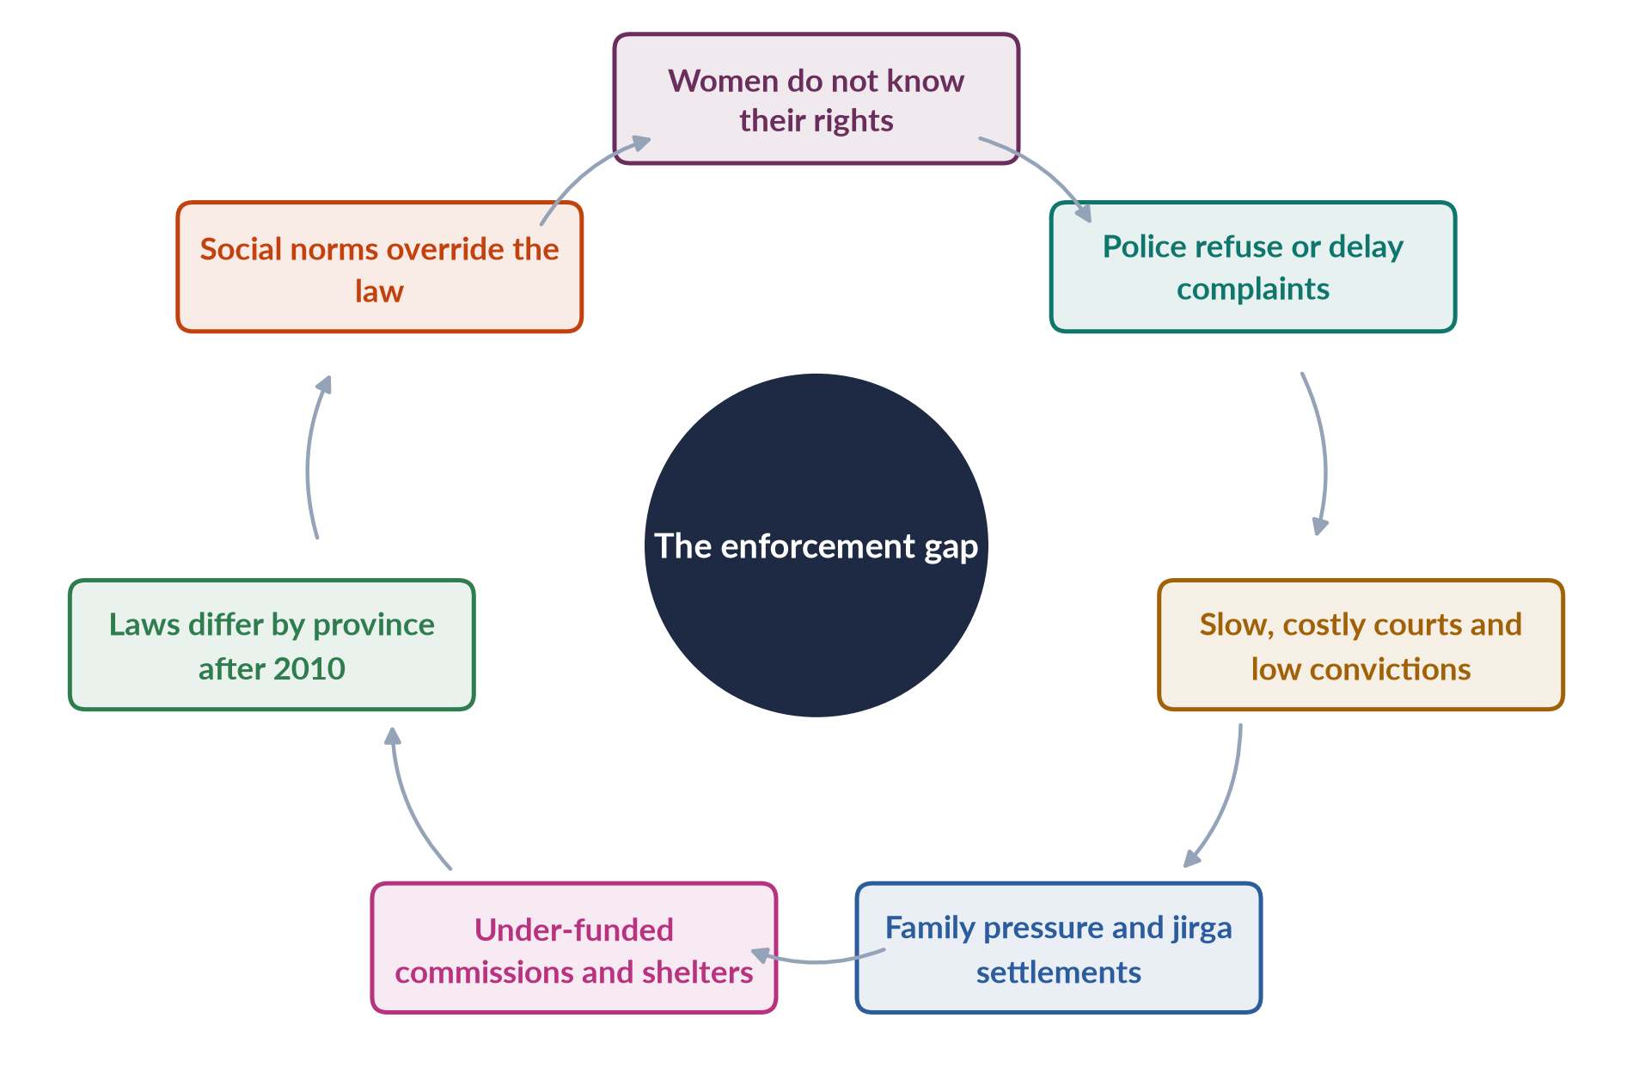
Figure 16 · Why laws fail women in practice.
1. Lack of awareness among women and officials.
2. Police attitudes and lack of women police.
3. Slow, costly justice; poor investigation and forensic evidence.
4. Family and community pressure; jirgas and panchayats making parallel "decisions".
5. Weak institutions — under-funded commissions, shelters and protection centres.
6. Uneven federalism — after the 18th Amendment (2010), provinces legislate separately; some laws exist in one province but not another.
7. Conflicting norms — laws seen by some as foreign or un-Islamic; the Council of Islamic Ideology has opposed several (for example the child-marriage law of 2025).

7.5a Shelters and protection services
Women escaping violence can go to government shelters (Dar-ul-Aman), crisis centres and, in Punjab, violence-against-women centres that combine police, medical, legal and counselling help under one roof. Helplines (such as the 1043 women's helpline in Punjab) and the provincial Rescue 1122 service also respond. But shelters are few, often overcrowded and poorly run; some women report being pressured to return home, and women with children or without family support have few options. Strengthening shelters — with safety, counselling, legal aid and pathways to work and housing — is central to making protective laws real.

7.6 Closing the gap
1. Legal literacy — teach women and men their rights through schools, media and LHWs.
2. Gender-sensitive policing — more women police, training, women's desks in every station.
3. Faster justice — special courts (as under the 2021 Act), legal aid, forensic labs.
4. One-stop centres for survivors in every district.
5. Strong, funded commissions with powers to investigate and follow up.
6. Harmonise laws across provinces — for example, an 18-year marriage age everywhere.
7. Engage religious scholars to show that protective laws serve Islamic justice.
8. Data — publish case data to track enforcement.
EXAMINER'S EYE · THE MODEL STRUCTURE FOR 2020
1. Introduction: the statement's three requirements; democratic welfare state; the NCHR Act 2012 wording. 2. Human rights and women — concept. 3. Guarantees: Constitution, treaties, laws (table). 4. Institutions (table). 5. Enjoyment: awareness, access, norms. 6. Remedies: police, courts, commissions. 7. The enforcement gap (cycle figure). 8. Evaluation: strong on paper, weak in practice; recent progress. 9. Way forward. 10. Conclusion. Draw the pyramid.

Chapter 8 · Intersectional Disadvantage: Rural, Minority, Disabled and Poor Women
"Using intersectionality as an analytical framework, examine the experiences of marginalized groups of women in Pakistan, including rural women, ethnic and religious minorities, and differently-abled women. How do overlapping systems of oppression shape their access to health, education and employment?" (2026). Topic 2 (Chapter 8) teaches the theory; this chapter applies it to Pakistan.

8.1 Intersectionality — a quick reminder
✦ DEFINITION
Intersectionality · Kimberlé Crenshaw (1989)
The idea that a person's identities — gender, class, place, religion, ethnicity, caste, disability, age — overlap and interact, producing unique disadvantages that cannot be understood one identity at a time. Disadvantages multiply, not simply add up.
➜ The question to ask before any claim about "Pakistani women": which women?

Patricia Hill Collins (1990) called the way these overlapping oppressions are organised a matrix of domination — working through laws and institutions, everyday practices and ideas.
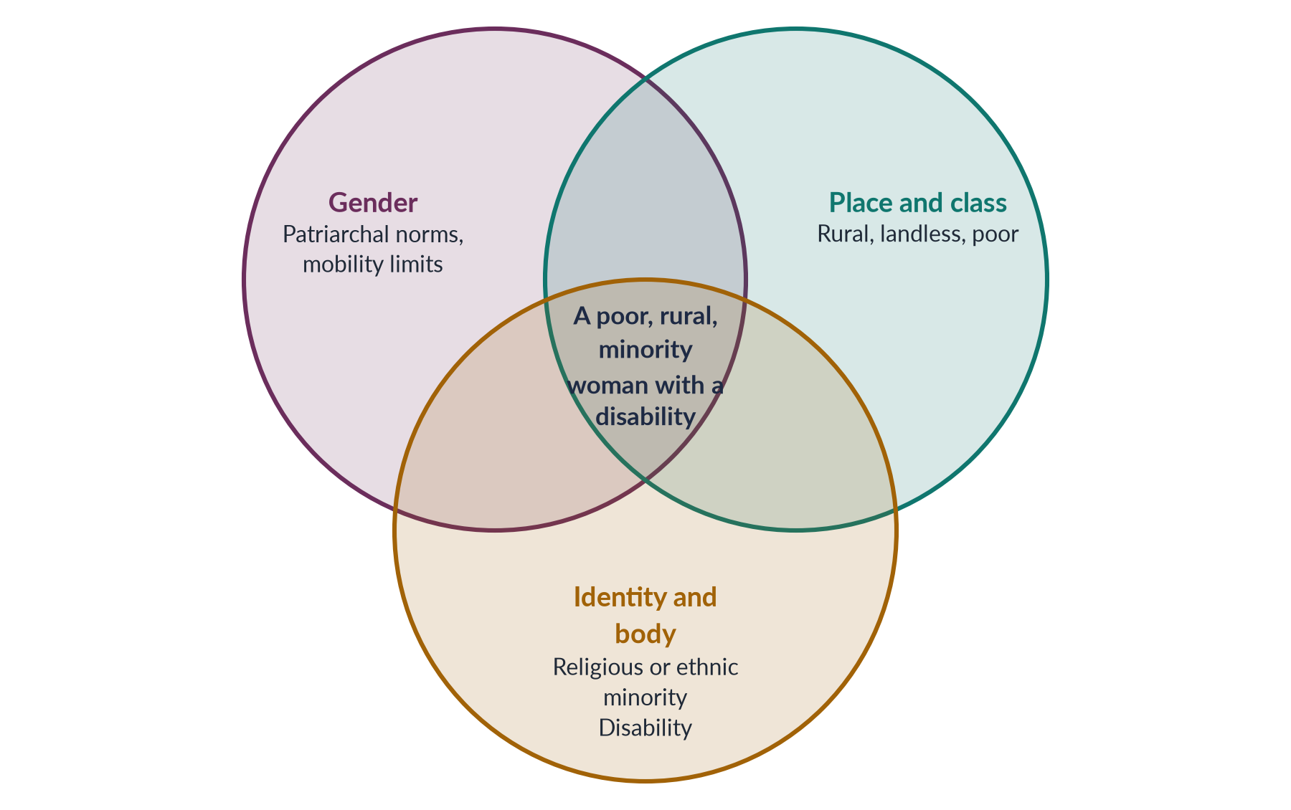
Figure 17 · Overlapping systems of disadvantage in Pakistan.

8.2 Rural women
Most Pakistani women live in rural areas.
- Health: distance to clinics, few female doctors, home births; rural maternal mortality far above urban.
- Education: rural female literacy far below urban; few secondary schools for girls.
- Employment: heavy unpaid farm and livestock work; seasonal cotton picking for low wages; almost no land ownership.
- Overlaps: feudal and tribal power, jirgas, customs such as vani and swara, and the risk of honour violence.

8.3 Religious minority women
Christian, Hindu, Sikh, Ahmadi and other minority women face gender plus religious disadvantage.
- Forced conversion and marriage: human-rights groups report cases each year of young Hindu and Christian girls, especially in Sindh and Punjab, abducted, converted and married; courts and police often fail to protect them.
- Caste and poverty: many scheduled-caste Hindu women in Sindh and Thar are landless labourers, sometimes in bonded labour; many Christian women work as sanitation workers and domestic workers, in stigmatised, unsafe jobs.
- Education: discrimination in textbooks and schools; poverty keeps girls out of school.
- Health: poor access in low-income settlements.
- Legal recognition: until the Sindh Hindu Marriage Act 2016 and the federal Hindu Marriage Act 2017, Hindu marriages could not be registered — leaving women without proof of marriage for inheritance, divorce or identity documents.
- Ahmadi women face legal and social discrimination against their community on top of gender norms.

8.4 Ethnic minority women
- Hazara women in Quetta have lived through targeted attacks on their community; many are widows supporting families under restricted movement.
- Baloch women in remote districts face the worst health and education indicators in the country, and conflict adds insecurity.
- Women of former tribal areas (now merged with Khyber Pakhtunkhwa, 2018) faced militancy, school destruction and very limited services.
- Afghan refugee women face legal insecurity and poverty.

8.5 Women with disabilities
- Women with disabilities face stigma, exclusion from school, lack of accessible transport and buildings, and very limited work.
- Marriage prospects are poor, and they face higher risks of violence and abuse.
- Health services are rarely accessible, especially reproductive care.
- Laws exist: a job quota for persons with disabilities since the Disabled Persons (Employment and Rehabilitation) Ordinance 1981; the ICT Rights of Persons with Disability Act 2020; provincial laws; Pakistan ratified the UN Convention on the Rights of Persons with Disabilities in 2011. Implementation is weak, and data on disabled women are poor.

8.6 Poor and informal women workers, and *khawaja siras*
- Home-based and domestic workers — poverty, informality and gender combine; no contracts, pensions or protection.
- Widows and women-headed households — lack of land, identity documents and male "protection" limits access to aid.
- Khawaja siras — gender identity, poverty and social exclusion overlap; many are excluded from family, schooling and jobs (Topic 1, Chapter 11).

8.6a Older women and widows
Older women and widows form another marginalised group. Widows are often denied their husband's property by in-laws, may be pressured to remarry within the family, and lose social standing. Older women have little income of their own, few pensions (most women never worked in the formal sector), and growing health needs — including chronic diseases and disability — with limited access to care. Social protection such as BISP and provincial old-age support can help, but many older women lack the identity documents needed to claim it.

8.7 How overlapping oppression shapes access
Table 10 · Access to health, education and employment for marginalised women.
Group | Health | Education | Employment
Rural women | Distance; few female staff; home births | Few girls' secondary schools; low literacy | Unpaid farm work; no land
Minority women | Poor settlements; discrimination | Poverty; biased textbooks; forced marriage | Sanitation, domestic and bonded work
Ethnic minorities | Worst indicators (Balochistan); conflict | School destruction; insecurity | Restricted movement; few jobs
Disabled women | Inaccessible clinics; reproductive neglect | Excluded from schools | Quota unfilled; stigma
Poor informal workers | Cost of care | Girls kept home to work | No contracts or protection

8.7a Two lives compared
Consider two women of the same age. The first is a Muslim woman from a middle-class family in Lahore: she finished university, works in a bank, uses mobile banking and consults a woman doctor through a telemedicine app. The second is a young Hindu woman from a landless family in Tharparkar: she never went to school, fetches water for hours each day, gave birth at home at sixteen, works in the fields for a landlord to whom her family owes money, and cannot register her marriage or get an identity card easily. Both are "Pakistani women" — but gender interacts with class, place and religion to give them almost entirely different lives. This is what intersectionality asks policy to see.

8.8 Why an intersectional lens matters for policy
1. Averages hide the worst-off — national figures (literacy 53%, LFPR 24.4%) mask far worse outcomes for these groups.
2. Single-axis policies miss people — a women's programme may not reach minority women; a disability programme may not reach disabled women.
3. Design for the overlap — mobile clinics for rural women; accessible girls' schools; legal protection against forced conversion; social security for home-based workers; CNIC drives for poor women.
4. Data — collect statistics by sex and religion, disability, region and income.
5. Voice — include marginalised women in commissions and planning.
EXAMINER'S EYE · THE MODEL STRUCTURE FOR 2026 Q7
1. Introduction: define intersectionality (Crenshaw 1989; Collins 1990); "which women?"; averages hide the worst-off. 2. Rural women. 3. Religious minority women. 4. Ethnic minority women. 5. Women with disabilities. 6. Health, education and employment across groups (table). 7. The matrix of domination in Pakistan — laws, institutions, norms. 8. Policy for the overlaps. 9. Conclusion. Draw the Venn figure.

Chapter 9 · The Digital Gender Gap
A 2026 short note asked about the "gendered implications of digital transformation and the narrowing mobile gender gap in Pakistan (2024–2025), including the fact that eight million more women came online and the mobile internet gender gap fell from 38% to 25%." This chapter explains the gap, its causes, its recent narrowing and what it means for women.

9.1 What the digital gender gap is
✦ DEFINITION
Digital gender gap · three layers
The difference between women and men in (1) access — owning a phone or using the internet; (2) skills and use — the ability to use digital services; and (3) benefits — using digital tools to learn, earn, bank, get health care or information, and be safe online.

The organisation that measures the mobile gender gap across low- and middle-income countries is the GSMA (the association of mobile operators), in its annual Mobile Gender Gap Report.

9.2 Pakistan's recent progress
✦ DATA
The narrowing mobile-internet gender gap · GSMA, as cited in the CSS 2026 paper
Between 2024 and 2025, Pakistan's mobile-internet gender gap fell from 38% to 25%, and about eight million more women came online. A gap of 25% means women are still a quarter less likely than men to use mobile internet.

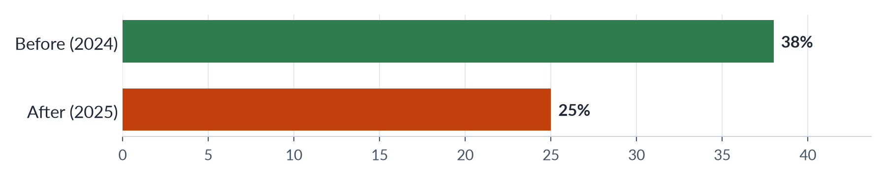
Figure 18 · Pakistan's mobile-internet gender gap (%).
What drove the change:
1. Cheaper smartphones and data.
2. Digital payments — BISP and other cash transfers paid through mobile accounts and biometric systems bring women into digital finance.
3. Awareness and skills programmes by government, operators and NGOs.
4. Social media and online work — women's use of messaging, video and freelancing platforms.
5. Identity cards — more women registered for CNICs, which are needed to buy a SIM card.

9.2a Pakistan in the global picture
Across low- and middle-income countries, the GSMA has long reported that South Asia has the widest mobile gender gaps in the world, and Pakistan has been among the widest within the region. The narrowing to 25% is therefore significant — but it still leaves Pakistan behind many peers. The gap is widest among rural, older, less-educated and poorer women, which means the digital divide is itself intersectional: a young, educated urban woman may be almost as connected as a man, while a rural woman with no schooling may have no phone of her own at all.
IN SIMPLE WORDS
A phone today is a bank, a school, a clinic, a job centre and a newspaper. A woman without one is shut out of all five. That is why the digital gap matters for every other dimension of women's status.

9.3 Why the gap exists — the barriers
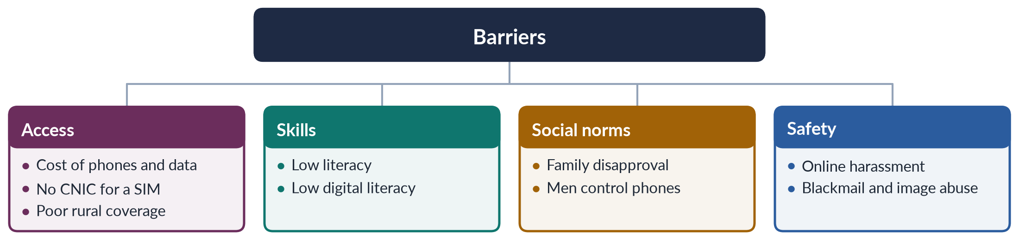
Figure 19 · Barriers to women's digital inclusion in Pakistan.
1. Affordability — phones and data are a larger burden for women with little or no income.
2. Identity documents — a SIM must be registered to a CNIC; many rural women lack one.
3. Literacy — low female literacy (about 53%) limits use of text-based services.
4. Social norms — families may disapprove of girls and women owning phones; phones are often shared or controlled by male relatives.
5. Online harassment — abuse, blackmail, doxxing and fake images drive women offline; many do not report.
6. Relevance — few services designed for women in local languages.

9.4 Gendered implications of digital transformation
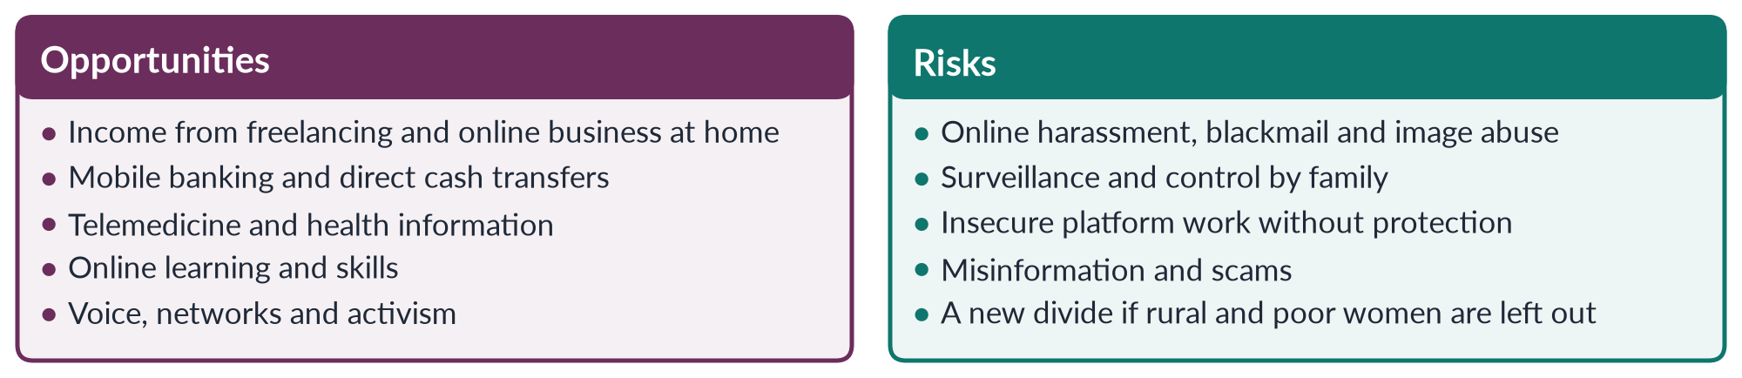
Figure 20 · Digital transformation: opportunities and risks for women.

(1) Economic
Women whose mobility is restricted can earn from home through freelancing, e-commerce and social-media businesses; mobile wallets give them money in their own names.

(2) Health and education
Telemedicine platforms connect women patients with women doctors; online learning reaches girls who cannot attend distant schools.

(3) Social protection
BISP payments through biometric and digital systems reduce leakages and reach women directly.

(4) Voice and activism
Social media amplified campaigns such as the Aurat March and responses to violence (Topic 3).

(5) Safety risks
The Prevention of Electronic Crimes Act 2016 criminalises online harassment and image-based abuse (it was amended in 2025); the FIA's cybercrime wing handles complaints; the Digital Rights Foundation runs a cyber-harassment helpline (from 2016). Many women still fear reporting.

9.4a Women in the digital economy
Pakistan is one of the world's larger sources of online freelancers, and women form a growing share, working from home in writing, design, programming, virtual assistance and online teaching. Social-media commerce lets women sell clothes, food and crafts from home. For women whose families restrict their movement, this is a real opening. But online work is insecure — no contracts, pensions or protection — and payment systems can be hard to access without a bank account or CNIC. Digital skills programmes and women's access to digital finance are therefore as important as phones themselves.

9.4b Reporting online harassment
A woman who is harassed or blackmailed online can complain to the Federal Investigation Agency (FIA) cybercrime wing (now being moved to a new cybercrime agency) under PECA 2016, or seek help from the Digital Rights Foundation's helpline. In practice, many women hesitate: they fear their families will blame them or take away their phones, and complaint processes can be slow. Surveys by digital-rights groups suggest that most women who face online harassment never report it. Faster, confidential and women-friendly reporting — with female investigators — would encourage more women to use their legal protection.

9.5 The way forward
1. Close the access gap — affordable devices and data; CNIC registration drives for women; rural coverage.
2. Digital skills — through schools, LHWs, BISP and women's centres.
3. Safety by design — faster, women-friendly cybercrime reporting; platform accountability.
4. Women-centred services — health, finance, agriculture and legal information in local languages and voice.
5. Protect digital workers — social security and fair terms for freelancers.
6. Data — track the gap by sex, region and income.
7. Link to SDG target 5.b — use technology to empower women.
EXAMINER'S EYE · SHORT NOTE ON THE DIGITAL GAP (2026)
Define the gap (access, skills, benefits); the GSMA figures (38% → 25%; eight million more women online); drivers of progress; remaining barriers (cost, CNIC, literacy, norms, harassment); implications (opportunities and risks — compare figure); policy (three or four points). About 600 words.

Chapter 10 · Women's Political Status and Climate Vulnerability
Political empowerment is one of the four sub-indices of the Global Gender Gap (2026 Q4), and climate impacts appeared in 2026 Q5 (answered in Topic 4). This chapter gives the essentials for status questions; Topic 6 covers women and governance in full.

10.1 Women's political status
✦ DATA
Women in politics in Pakistan · latest figures
• The National Assembly has 336 seats: 266 general, 60 reserved for women and 10 for non-Muslims.
• In the 2024 general election, 306 women contested general seats and only 11 won.
• In 2025 the share of women among federal ministers fell to zero (Global Gender Gap Report 2025).
• Maryam Nawaz became the first woman chief minister (Punjab) in February 2024.
• Pakistan ranked 107th on political empowerment in the Global Gender Gap Report 2026.

Key facts:
1. Reserved seats — 60 in the National Assembly and 17 in the Senate since 2002; filled by party lists in proportion to general seats won.
2. Firsts — Benazir Bhutto, first woman prime minister of a Muslim-majority country (1988); Fahmida Mirza, first woman Speaker (2008).
3. The Elections Act 2017 requires parties to give at least 5% of general-seat tickets to women, and allows the Election Commission to declare void a constituency result where women's turnout is below 10%.
4. Women voters — millions fewer women than men are registered to vote, largely because of missing CNICs; registration drives have narrowed the gap.
5. Barriers — family and tribal opposition, the cost of campaigns, party patronage, harassment, and agreements in some areas to stop women voting.

10.1a The women-voter gap and local government
Millions fewer women than men are on the electoral rolls, mainly because many women lack CNICs; the Election Commission, NADRA and civil-society groups have run registration drives to close this gap. In some areas, local agreements among elders have tried to stop women voting — which is why the Elections Act 2017 lets the Election Commission void results where women's turnout is under 10%. At the local level, the devolution plan of 2000–01 reserved 33% of local-council seats for women, bringing tens of thousands of women into elected office for the first time; later provincial local-government laws reduced this share in several provinces.

10.1b Women in the bureaucracy and judiciary
Women's status also depends on their presence in the state machinery. The 10% quota in federal services, together with rising female education, has increased the number of women officers in the civil service, including in the police and foreign service. In the judiciary, women have been appointed as judges of the high courts and, since 2022, of the Supreme Court. Yet women remain a small minority in senior posts. More women in decision-making positions in the bureaucracy, police and courts improves the handling of cases involving women — for example, complaints of violence and harassment.

10.2 Why political status matters for other dimensions
Women legislators, especially through the cross-party Women's Parliamentary Caucus (2008), drove many of the laws of 2010–2016 — on harassment, acid attacks, anti-women practices and honour crimes. Without women in power, health, education and employment policies are less likely to address women's needs.
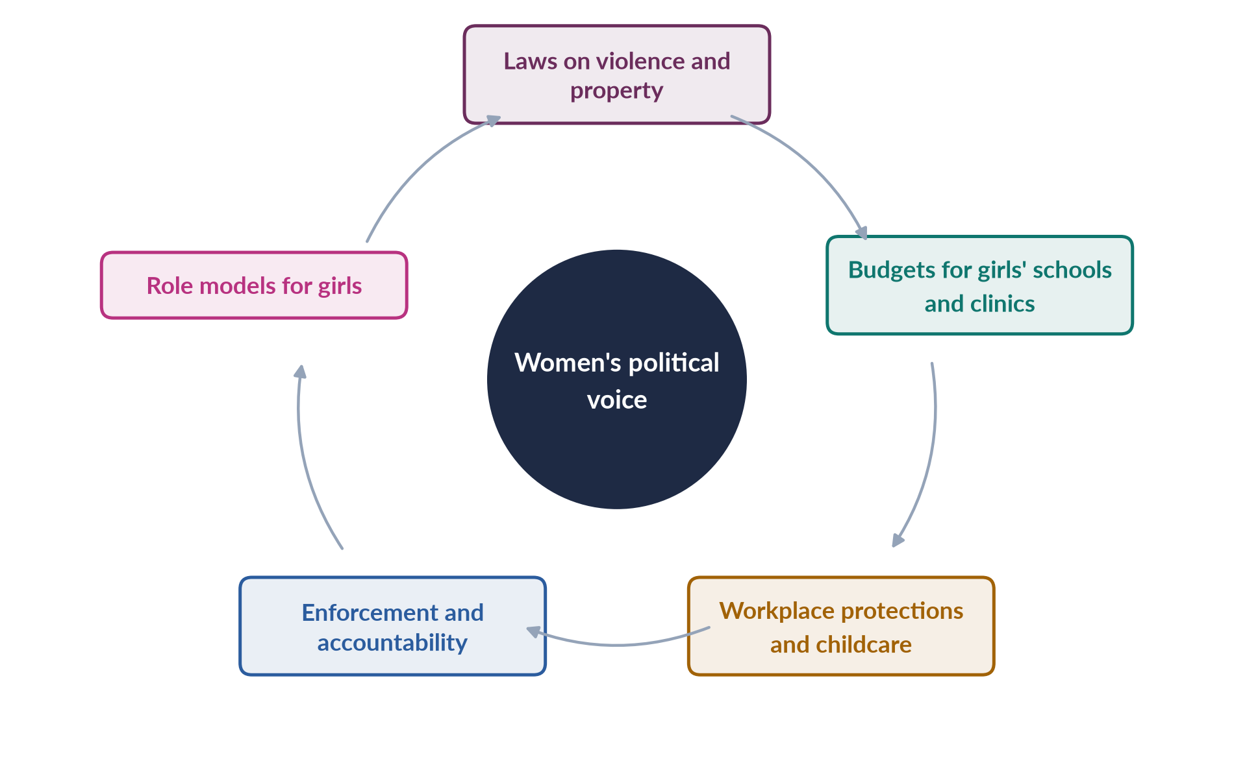
Figure 21 · How political voice links to other dimensions of status.

10.3 Climate change and women's status
Pakistan produces less than 1% of global emissions but is among the countries most affected by climate change. Climate shocks worsen every dimension of women's status:
- Health: the 2022 floods left about 650,000 pregnant women in affected areas (UNFPA); heat waves raise risks in pregnancy.
- Education: thousands of schools were damaged; girls are more likely to drop out after disasters.
- Employment: women lost livestock, crops and home-based work; they own little land to recover.
- Law and protection: relief registered to male heads of household and requiring CNICs left many women out; reports of early marriage after disasters.
Topic 4, Chapter 14 analyses climate impacts through ecofeminism and feminist environmentalism.

10.3a Heat waves and women's status
Recurrent heat waves — with temperatures near or above 50°C in cities such as Jacobabad — affect women in specific ways. Women cooking over open fires in poorly ventilated kitchens, and women working in fields during harvests and cotton picking, face serious heat stress. Pregnant women face higher risks of complications. As water sources dry up, the time women spend fetching water grows. Power cuts during heat waves make homes hotter, and home-based workers lose income when they cannot work. Heat-action plans rarely consider these gendered risks.

10.4 Putting the dimensions together
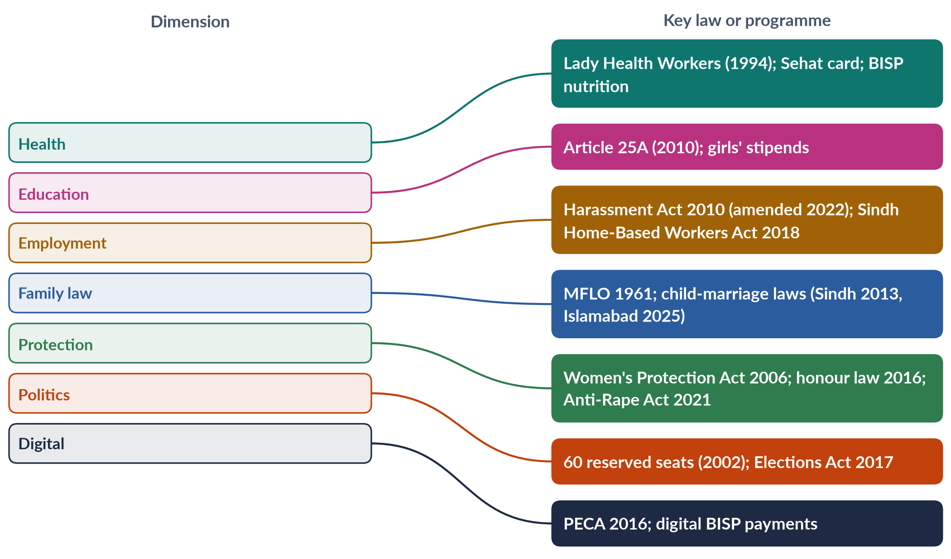
Figure 22 · The dimensions of women's status and their key laws or programmes.
EXAMINER'S EYE · IMPROVING WOMEN'S STATUS "AS A WHOLE" (2023)
The 2023 question asked for measures to improve women's status "as a whole". Link the dimensions: education raises health and earnings; health enables work; work gives voice and bargaining power; law protects; political voice turns needs into policy. The best answers show these links, using this chapter's mapping figure.

Part Two — Today's Debates
Topic 5 is where the newest questions land — the gender-gap ranking, intersectionality and the digital gap. These are the live debates. Each gives you facts, both sides and a line to take.

Debate 1 · Did Pakistan really improve in 2026?
Pakistan rose from 148th of 148 (2025) to 143rd of 145 (2026), with its score up from 56.7% to 59.5% — its strongest gain in a decade, driven by education and political empowerment (each up 11 places).
- Optimists: the rise reflects real gains in girls' schooling and women's political roles.
- Sceptics: fewer countries were ranked; the economic gap (144th) barely moved; female labour-force participation is still 24.4%.
- Line to take: welcome progress, but the economic gap is the real test.

Debate 2 · Why do so few Pakistani women work?
Female participation (24.4%) is among the lowest in the world, far below Bangladesh. Explanations compete: norms (honour, purdah), safety (harassment, transport), care (no childcare), jobs (few suitable jobs near home), and measurement (unpaid farm work under-counted).
- Line to take: all matter; the fastest levers are safe transport, childcare, enforcement of the harassment law and home-based/digital work with protection.

Debate 3 · Child marriage: 16 or 18?
Sindh (2013) and Islamabad (2025) set 18; Punjab's Assembly passed a bill in 2026; elsewhere the girls' age remained 16.
- For 18: health (adolescent pregnancy risks), education, international commitments (SDG 5.3, CRC); the Federal Shariat Court (2021) held a minimum age is not against Islam.
- Against (some religious bodies, including the Council of Islamic Ideology): Islam links marriage to puberty; the state should not fix an age.
- Line to take: 18 protects girls' health and schooling and is consistent with the FSC's view; enforcement and registration matter as much as the law.

Debate 4 · Laws on paper, violence in practice
Pakistan has passed many protective laws since 2006, yet violence and low conviction rates persist. Debate: are more laws needed, or better enforcement?
- Line to take: the priority is enforcement — policing, courts, shelters, legal aid and awareness (Chapter 7).

Debate 5 · Inheritance: rights denied by custom
Islamic law gives women shares; custom often denies them. The 2011 and 2020 laws created remedies, but few women use them for fear of breaking family ties.
- Line to take: combine legal remedies with automatic mutation of land records in heirs' names, awareness through religious scholars, and support for women who claim.

Debate 6 · The digital gap: opportunity or new danger?
The gap fell from 38% to 25%, but online harassment and control of phones by families remain. The debate asks whether digital inclusion empowers women or exposes them to new control.
- Line to take: both; pair access with skills and safety (Chapter 9).

Debate 7 · Health spending and the female health workforce
Health spending has long been around 1% of GDP, and many women medical graduates do not practise. Proposals: expand LHWs and midwives, telemedicine, incentives for rural posts, and bonding requirements for publicly funded medical graduates (controversial).

Debate 8 · Leaving no woman behind
The 2026 intersectionality question reflects a wider debate: whether national averages hide the worst-off — minority, rural and disabled women. Line to take: collect disaggregated data and design programmes for the overlaps (Chapter 8).

Part Three — The Examiner's Record of Topic 5

Every question, 2016–2026
Table 11 · Every question the examiner has set on T5, 2016–2026.
Year · Q | The question (as set) | Family
2017 · Q5 | What is the status of women's health in Pakistan? How could it be improved within the available economic resources? | Women's health in Pakistan
2018 · Q5 | What reasons are responsible for ranking Pakistan as the second-worst country in the world for gender inequality despite Pakistan's commitment to many international conventions and the strong commitment to gender equality in the 1973 Constitution? | Pakistan and the Global Gender Gap; Women, law and human rights
2019 · Q6 | Women's participation in the labour force has increased recently, yet women continue to perform their reproductive roles. Discuss the challenges encountered by women as a result of paid employment worldwide, with special reference to Pakistan. | Women and paid employment
2020 · Q6 | 'For realizing, in letter and spirit, the ideals of a democratic welfare state, it is necessary to institute a system which fully guarantees human rights, generates a conducive environment for the pragmatic use and beneficial enjoyment of human rights, and provides operative safeguards and expeditious remedy against any violation of human rights.' Critically evaluate the statement with special reference to Pakistan. | Women, law and human rights
2023 · Q7 | Elucidate the current health status of women in Pakistan. What measures could be taken to improve women's status as a whole? Support your arguments with suitable examples. | Women's health in Pakistan
2024 · Q2 | An Egyptian doctor, Mahmoud Fathalla, uses the term 'maternity death road' while discussing issues of women's maternal health. Discuss women's health issues in the context of Pakistan's social, cultural and demographic situation. | Women's health in Pakistan
2026 · Q4 | Evaluate Pakistan's performance in the World Economic Forum's Global Gender Gap Report 2025. Identify the socio-economic and political factors contributing to Pakistan's ranking, including labour-force participation, education, health and political empowerment. | Pakistan and the Global Gender Gap
2026 · Q7 | Using intersectionality as an analytical framework, examine the experiences of marginalized groups of women in Pakistan, including rural women, ethnic and religious minorities, and differently-abled women. How do overlapping systems of oppression shape their access to health, education and employment? | Intersectionality
2026 · Q8(a) | Short note: Gendered implications of digital transformation and the narrowing mobile gender gap in Pakistan (2024-2025), including the fact that eight million more women came online and the mobile internet gender gap fell from 38% to 25% | The digital gender gap

What the record reveals
- Eight full questions and one short note (8.5 visits), and 19 of the 140 MCQs — mostly laws and dates.
- Health is the favourite line: 2017, 2023 and 2024 — the 2024 question quoted a named doctor (Mahmoud Fathalla).
- The ranking returns: Pakistan's gender-gap ranking in 2018 (second-worst) and 2026 (the 2025 report).
- 2026 brought three new lines: the Global Gender Gap 2025, intersectional disadvantage, and the digital gender gap — the examiner reads current reports.
- Education has never been a full question — the clearest blind spot in the paper.
- Employment was asked once (2019) and law/human rights once (2020); both are due in new forms.

Five likely questions
1. "Discuss the status of women's education in Pakistan. What are the causes of the gender gap, and how can it be closed?" (Chapter 4.)
2. "Pakistan has a strong body of pro-women laws but weak implementation. Critically examine." (Chapter 7.)
3. "Why is female labour-force participation in Pakistan among the lowest in the world? Suggest a policy response." (Chapter 5.)
4. "Evaluate the rights of women under the Constitution of Pakistan and the Muslim Family Laws Ordinance 1961." (Chapter 6.)
5. "Women's health in Pakistan is a development issue, not only a medical one. Discuss." (Chapters 2–3.)
These are not solved here; the Prediction Papers include answers to predicted questions. Plan each as an answer map for practice.

Part Four — The One-Liner Bank
About 120 one-liners in the style of the past MCQs. Each is a complete, checkable fact: the key word is in bold green and the date in bold navy. Read them aloud; cover the bold words and test yourself; then attempt every past MCQ below.

The one-liners

A · Measuring status
1. The Global Gender Gap Index of the World Economic Forum began in 2006.
2. Its four sub-indices are economic participation, educational attainment, health and survival, and political empowerment.
3. In 2006 Pakistan ranked 112th of 115.
4. In 2017 Pakistan ranked 143rd of 144 — the "second-worst" country (2018 question).
5. Pakistan's rank in the Global Gender Gap Report 2023 was 142nd of 146 (MCQ 2024).
6. In the Global Gender Gap Report 2025 Pakistan ranked last, 148th of 148, with 56.7% of the gap closed.
7. In 2025 the share of women among Pakistan's federal ministers fell to zero.
8. In 2026 Pakistan rose to 143rd of 145, with 59.5% of the gap closed.
9. In 2026 Pakistan ranked 144th on economic participation, 130th on education and 107th on political empowerment.
10. The global gender gap was 69.2% closed in 2026; parity is 120 years away; Iceland ranked first.
11. The UNDP's Gender Inequality Index began in 2010; the Gender Development Index in 1995.
12. The index measures gaps, not absolute well-being.

B · Health
13. Pakistan's maternal mortality ratio was 186 per 100,000 live births (PMMS 2019).
14. About 42% of women of reproductive age were anaemic (National Nutrition Survey 2018).
15. About 40% of children under five were stunted (NNS 2018).
16. The total fertility rate was about 3.6 (PDHS 2017–18).
17. About 34% of married women used contraception (PDHS 2017–18).
18. About two-thirds of births were assisted by a skilled provider (PDHS 2017–18).
19. A 2019 paper stated that about 13,000 lives a year are lost in Pakistan to breast cancer (MCQ 2019).
20. The WHO defines health as complete physical, mental and social well-being (1946).
21. The Lady Health Worker Programme began in 1994 under Benazir Bhutto.
22. The Supreme Court ordered the regularisation of Lady Health Workers in 2012.
23. The Sehat Sahulat Programme (health card) was launched in 2015–16.
24. Public spending on health has long been around 1% of GDP.
25. After the 18th Amendment (2010), health became a provincial subject.
26. Pakistan introduced the HPV vaccine for girls in 2025.

C · Maternal health and Fathalla
27. Mahmoud Fathalla, an Egyptian obstetrician, described the "road to maternal death" (2024 question).
28. Fathalla asked "Why did Mrs X die?" at the Safe Motherhood Conference, Nairobi, 1987.
29. The Nairobi conference launched the global Safe Motherhood Initiative (1987).
30. Fathalla: women die not of untreatable diseases but because societies have not decided their lives are worth saving.
31. Thaddeus and Maine (1994) described the three delays: deciding, reaching and receiving care.
32. The main causes of maternal death are haemorrhage, hypertension, infection, obstructed labour and unsafe abortion.
33. SDG target 3.1: a global maternal mortality ratio below 70 by 2030.
34. Pakistan's population was about 241 million in the Census 2023, growing at about 2.55% a year.
35. About 650,000 pregnant women were in areas affected by the 2022 floods (UNFPA).

D · Education
36. Article 25A (18th Amendment, 2010) requires free and compulsory education for ages 5 to 16.
37. The Census 2023 literacy rate was 60.65% — about 68% for men and 53% for women.
38. The female literacy rate stated in a 2019 paper was 48% (MCQ 2019).
39. More than 25 million children in Pakistan are out of school, most of them girls.
40. Balochistan has the lowest female literacy in Pakistan.
41. Malala Yousafzai was shot on 9 October 2012 and won the Nobel Peace Prize in 2014.
42. Militants banned girls' education in Swat in 2007–2009.
43. Punjab's female school stipend (from 2004) raised girls' secondary enrolment.
44. The "doctor brides" phenomenon: many women medical graduates never practise.

E · Employment
45. Female labour-force participation was 24.4% in the LFS 2024–25 (21.4% in 2020–21).
46. Female LFPR by province: Punjab 33.8%, KP 21.1%, Sindh 20.5%, Balochistan 14.5%.
47. Artificial unseen barriers preventing career growth are called the glass ceiling (MCQ 2024).
48. The sticky floor refers to women stuck in low-wage, low-mobility jobs (MCQ 2026).
49. Comparable-worth discrimination refers to sex segregation and less pay for women's work (MCQ 2023).
50. Arlie Hochschild named the "second shift" (1989).
51. Women do about three times as much unpaid care work as men worldwide (ILO, 2018).
52. The Protection against Harassment of Women at the Workplace Act was passed in 2010 (MCQs 2016, 2018, 2019, 2024).
53. The harassment law was amended in 2022 to widen "workplace" and "employee".
54. A 10% quota for women in federal services was given under the PML-Q in 2002 (MCQ 2018 key).
55. Sindh passed the first Home-Based Workers Act in 2018.
56. Punjab passed a Domestic Workers Act in 2019.
57. The federal Maternity and Paternity Leave Act was passed in 2020.
58. Justice Ayesha Malik became the first woman judge of the Supreme Court in 2022.

F · Constitution and family law
59. Article 25: no discrimination on the basis of sex; special provision for women allowed.
60. Article 34: full participation of women in all spheres of national life.
61. Article 35: protection of marriage, family, mother and child.
62. Article 37(e): maternity benefits for women in employment.
63. Article 32: representation of women in local government.
64. The Muslim Family Laws Ordinance was enacted in 1961 (MCQs 2016, 2018).
65. Under the MFLO, a second marriage needs the permission of an Arbitration Council.
66. Under the MFLO, a talaq takes effect 90 days after notice to the Union Council.
67. The MFLO gave orphaned grandchildren a right to inherit.
68. The minimum age of girls for marriage under the old federal Child Marriage Restraint Act is 16 (MCQs 2016, 2019).
69. The Sindh Child Marriages Restraint Act 2013 set the age at 18.
70. The ICT Child Marriage Restraint Act 2025 set 18 in Islamabad (assent 30 May 2025).
71. The Punjab Assembly passed a child-marriage restriction bill in April 2026.
72. The Federal Shariat Court (2021) held a minimum marriage age is not against Islam.
73. The Dissolution of Muslim Marriages Act was passed in 1939.
74. Khurshid Bibi v. Muhammad Amin (1967) recognised a wife's right to khula.
75. The Saima Waheed case (SC 2004) upheld an adult woman's right to marry without a wali's consent.
76. The Family Courts Act was passed in 1964.
77. The Dowry and Bridal Gifts (Restriction) Act was passed in 1976.
78. The Sindh Hindu Marriage Act (2016) and federal Hindu Marriage Act (2017) allowed Hindu marriages to be registered.

G · Protective laws and institutions
79. The Hudood Ordinances were enacted in 1979.
80. The Protection of Women (Criminal Laws Amendment) Act 2006 was passed under Pervez Musharraf (MCQ 2016).
81. The 2006 Act moved rape from the Zina Ordinance to the Pakistan Penal Code.
82. The NCSW was established in 2000 under Pervez Musharraf (MCQ 2016).
83. The National Policy for Development and Empowerment of Women was launched in 2002 (MCQ 2018).
84. The Acid Control and Acid Crime Prevention Act was passed in 2011.
85. The Prevention of Anti-Women Practices Act 2011 criminalised forced marriage, vani*/*swara, and denial of inheritance.
86. Sindh passed the first provincial domestic violence law in 2013.
87. The anti-honour-killing law of October 2016 made life imprisonment mandatory even if the family forgives.
88. Qandeel Baloch was killed by her brother in July 2016.
89. The Prevention of Electronic Crimes Act was passed in 2016.
90. The Enforcement of Women's Property Rights Act (Islamabad) was passed in 2020.
91. The Anti-Rape (Investigation and Trial) Act of 2021 created special courts.
92. The National Commission for Human Rights was created by the NCHR Act 2012.
93. The 2020 question's wording echoes the preamble of the NCHR Act 2012.
94. The first violence-against-women centre opened in Multan in 2017.
95. Punjab's women's helpline number is 1043.
96. Pakistan ratified the ICCPR in 2010 and the ICESCR in 2008.

H · Intersectionality, digital and politics
97. Intersectionality was coined by Kimberlé Crenshaw in 1989.
98. Patricia Hill Collins (1990) described the matrix of domination.
99. Human-rights groups report forced conversion and marriage of Hindu and Christian girls, especially in Sindh and Punjab.
100. Pakistan ratified the Convention on the Rights of Persons with Disabilities in 2011.
101. A job quota for persons with disabilities dates from the Disabled Persons Ordinance 1981.
102. The former tribal areas merged with Khyber Pakhtunkhwa in 2018.
103. Pakistan's mobile-internet gender gap fell from 38% to 25% (GSMA, 2024–25).
104. About eight million more women came online in Pakistan in 2024–25.
105. The GSMA publishes the annual Mobile Gender Gap Report.
106. A SIM card in Pakistan must be registered to a CNIC.
107. The Digital Rights Foundation runs a cyber-harassment helpline (from 2016).
108. SDG target 5.b calls for using technology to empower women.
109. The National Assembly has 336 seats, including 60 reserved for women.
110. Only 11 women won general National Assembly seats in 2024.
111. Maryam Nawaz became the first woman chief minister (Punjab) in 2024.
112. Benazir Bhutto became prime minister in 1988; Fahmida Mirza the first woman Speaker in 2008.
113. The Elections Act 2017 requires 5% of tickets for women and allows voiding results where women's turnout is below 10%.
114. The Women's Parliamentary Caucus was formed in 2008.
115. The devolution plan of 2000–01 reserved 33% of local seats for women.
116. Pakistan emits less than 1% of global greenhouse gases.
117. Jacobabad is regularly among the hottest cities on earth.
118. The Benazir Income Support Programme (2008) pays cash to women.
119. The biggest single gap in Pakistan's gender-gap score is economic participation.
120. The central weakness of Pakistan's women's laws is the enforcement gap.

Every past MCQ on Topic 5
Table 12 · Every recovered MCQ on T5, with its key.
Year | Question | Key
2016 · 5 | The National Commission on the Status of Women was established under whose government? | A - Pervez Musharraf (established in 2000)
2016 · 7 | Minimum age of girls for marriage under the federal Child Marriage Restraint Act: | B - 16 years
2016 · 13 | The Protection of Women (Criminal Laws Amendment) Act 2006 was passed under whose government? | A - Pervez Musharraf
2016 · 14 | The anti-sexual-harassment law at the workplace was passed in: | C - 2010
2016 · 18 | The Muslim Family Laws Ordinance was enacted in: | C - 1961
2018 · 1 | Protection Against Harassment of Women at the Workplace Act was passed in: | C - 2010
2018 · 7 | The National Policy for Development and Empowerment of Women in Pakistan was launched in: | B - 2002
2018 · 18 | Protection against harassment of women at the workplace was promulgated in: | A - 2010
2018 · 19 | Muslim Family Laws Ordinance was passed in: | B - 1961
2018 · 20 | A 10% quota for women in federal services was given under: | C - PML-Q in 2002
2019 · 8 | The paper states that 13,000 lives per year are lost in Pakistan due to: | D - Breast cancer
2019 · 12 | Minimum age of a girl for marriage under the federal law referenced in the paper: | A - 16 years
2019 · 13 | The female literacy rate in Pakistan stated in the paper was: | A - 48%
2019 · 15 | Protection against harassment at the workplace was approved in: | A - 2010
2023 · 16 | Comparable-worth discrimination refers to: | C - Sex segregation and less pay for women's work
2024 · 2 | Artificial unseen barriers preventing career growth are called: | C - Glass ceiling
2024 · 8 | Protection against Harassment of Women at the Workplace Act was passed in: | B - 2010
2024 · 13 | Pakistan's rank in WEF Global Gender Gap Report 2023 (out of 146): | B - 142
2026 · 19 | 'Sticky floor' refers to: | A - Women stuck in low-wage, low-mobility jobs

TRAP · THREE MCQ TRAPS IN TOPIC 5
1. Harassment: 2010, not 2006. The workplace harassment law is 2010; the Women's Protection Act is 2006. Both appear often (the 2010 Act in five MCQs).
2. "The paper states…". Some MCQs quote figures from the paper itself (female literacy 48%, breast-cancer deaths 13,000). Choose the figure the stem attributes, even if newer data differ.
3. Minimum marriage age. Under the old federal law it is 16 for girls; Sindh (2013) and Islamabad (2025) set 18. Read whether the stem asks for federal, provincial or Islamabad law.

Part Five — The Revision Sheet
The whole of Topic 5 in a few pages, for the night before the exam. Every term is explained where it appears, so you will not need to turn back to the chapters.

1. What "status" means and the framework
- Status of women — women's position in society: rights, resources, respect and power compared with men's. Four syllabus dimensions: health, education, employment, law; plus politics, intersectionality, digital access, climate.
- Constitution 1973 — Art. 25 (equality; no discrimination on the basis of sex; special provision for women allowed); 25A (free, compulsory education 5–16, 18th Amendment 2010); 26–27 (no sex discrimination in public places or service); 32 (women in local government); 34 (full participation of women); 35 (protect marriage, family, mother, child); 37(e) (maternity benefits); 51, 59, 106 (reserved seats — 60 in the NA). Fundamental rights (Arts 8–28) are enforceable in court; Principles of Policy (29–40) are goals.
- Headline figures — MMR 186 (2019); female literacy ~53% (men ~68%; Census 2023); female LFPR 24.4% (2024–25); GGGR 2026 143/145.

2. Measuring status — the Global Gender Gap (2018, 2026)
- Global Gender Gap Index — World Economic Forum, since 2006; how much of the gap between women and men is closed (0–100%) in four sub-indices: economic participation and opportunity (labour force, wages, income, senior roles), educational attainment (literacy, enrolment), health and survival (sex ratio at birth, healthy life expectancy), political empowerment (parliament, ministers, heads of state). Measures gaps, not well-being.
- Other measures — UNDP GII (2010), GDI (1995); World Bank Women, Business and the Law; SDG 5 indicators.
- Pakistan's record — 2006 112/115; 2017 143/144 ("second-worst" — 2018 question); 2021 153/156; 2023 142/146 (MCQ 2024); 2025 148/148, 56.7%, zero women ministers; 2026 143/145, 59.5% (strongest gain in a decade), sub-ranks economic 144th, education 130th, political 107th; lowest in South Asia and of 38 lower-middle-income economies. Global gap 69.2%, parity 120 years, Iceland first. Distinguish rank from score.
- Why so low (four sub-indices) — economic: LFPR 24.4% vs roughly 80% for men; one of the widest pay gaps (ILO); few women managers; informal/unpaid work. Education: literacy 53/68; 25m+ out of school, mostly girls; rural, Balochistan and KP gaps. Health: sex ratio, MMR 186, anaemia. Politics: 60 reserved seats but only 11 women won general seats (2024); no women ministers (2025).
- Why commitments (Constitution, CEDAW 1996, Beijing 1995, SDGs 2015) have not closed the gap — enforcement gap; patriarchal norms (purdah, honour, son preference, early marriage); poverty and low spending (health ~1%, education ~2% of GDP); unsafe transport and harassment; unpaid care, no childcare; weak political will and voice; crises (militancy, 2022 floods, economic crises); uneven provincial capacity after the 18th Amendment (2010).
- South Asia — Bangladesh (garment jobs, women leaders), Sri Lanka (literacy, maternal health), Nepal (2015 quotas) show policy, not religion or region, decides.
- Moving up — women's paid work (transport, childcare, harassment law, protected home/digital work); pay gap; senior posts; girls' secondary schooling; maternal health; appoint women ministers.
- Critique of the index — consistent and comparable vs measures gaps not well-being, misses violence, unpaid care and informal work, data dated, rank swings. Signal, not whole story.

3. Women's health (2017, 2023)
- Definition — WHO (1946): complete physical, mental and social well-being. Life cycle: before birth/infancy (son preference) → childhood (malnutrition) → adolescence (early marriage, anaemia) → reproductive years → older age (NCDs, cancers).
- Indicators — MMR 186 (PMMS 2019); anaemia ~42% of women 15–49 (NNS 2018); stunting ~40% of under-fives (NNS 2018); TFR ~3.6; contraceptive use ~34%; skilled birth attendance ~two-thirds (PDHS 2017–18); health spending ~1% of GDP.
- Problems — maternal death; malnutrition and anaemia (women eat last; intergenerational cycle); high fertility; early marriage; RTIs and fistula; breast cancer (MCQ 2019: ~13,000 deaths a year; late diagnosis; October awareness month) and cervical cancer (HPV vaccine introduced 2025); NCDs; mental health (depression and anxiety from violence, isolation, forced marriage; few psychiatrists; stigma); violence; disasters (650,000 pregnant women in 2022 flood areas).
- Causes — social/cultural (son preference, early marriage, restricted mobility, low decision power, preference for female doctors); economic (poverty, food insecurity, costs — mostly out-of-pocket); health system (low spending, few female staff, rural gaps, women graduates not practising); education (low literacy, taboos).
- Programmes — LHW Programme 1994 (Benazir; ~1,000 people per LHW; family planning, antenatal care, immunisation; SC regularisation 2012; jobs for rural women); community midwives; Sehat Sahulat health card (2015–16; hospital care, not primary care); BISP and Benazir Nashonuma; Arts 35 and 37(e); health provincial after 2010.
- Improve within available resources (2017) — primary care first; LHWs and midwives; family planning; iron, folic acid, fortification; skilled birth attendance and referral; female workforce and telemedicine; cancer screening awareness; engage men and mothers-in-law; enforce child-marriage laws; target with BISP data; mental health in primary care.
- Status "as a whole" (2023) — link health to education, work, law and political voice.

4. Maternal health and Fathalla (2024)
- Mahmoud Fathalla — Egyptian obstetrician (later FIGO president); Safe Motherhood Conference, Nairobi 1987 (launched the Safe Motherhood Initiative); "Why did Mrs X die?"; maternal death = end of a long road built by society; most deaths preventable; "women are not dying because of diseases we cannot treat… but because societies have yet to decide their lives are worth saving".
- The road — born female and poor → undernourished and anaemic → little schooling → married young → no family planning, many close pregnancies → no antenatal care → complication (haemorrhage, eclampsia, obstructed labour, infection, unsafe abortion) → delays → death.
- Three delays (Thaddeus and Maine 1994) — deciding (danger not recognised; permission; cost), reaching (distance, roads, transport, floods), receiving care (no staff, blood, drugs, theatre).
- Data — MMR 186 (worse in rural areas, Balochistan); skilled attendance ~two-thirds; anaemia ~42%; TFR 3.6; contraception 34%, unmet need ~1 in 6; SDG 3.1 MMR < 70 by 2030.
- Social context — son preference; literacy 53%; poverty; low decision power.
- Cultural context — early marriage (girls' federal age 16; 18 only in Sindh 2013, Islamabad 2025; Punjab bill 2026); purdah and escorts; female-doctor preference; home births with dais; taboos; pressure for sons.
- Demographic context — 241 million (Census 2023), growing 2.55%; young; rural majority; regional inequality; floods.
- Closing the road — delay marriage, keep girls in school; nutrition; family planning (LHWs, pharmacies, scholars); antenatal care (WHO: 8 contacts); skilled attendance; emergency obstetric care with blood banks, ambulances (Rescue 1122); female workforce; community awareness; maternal death reviews.
- Pakistani "Mrs X" — Balochistan girl: fed last, left school (distant school), married at 15, six births, anaemia, bleeding at home, waited for husband, four hours to blood — every stage a policy failure.

5. Women's education (never asked — blind spot)
- Why it matters — later marriage; fewer, healthier children; antenatal care and immunisation; higher earnings; voice; knowledge of rights; educated daughters (virtuous cycle).
- Article 25A (2010) — free, compulsory education 5–16; provincial laws; weak enforcement.
- Status — literacy 60.65% (men ~68%, women ~53%; Census 2023); 2019 paper 48% (MCQ); WEF female literacy ~48.5% (2025); 25m+ out of school, mostly girls; education rank 130th (2026); dropout after primary; women ~half of university students, majority in medicine; low learning; missing facilities.
- Provinces — Punjab and Islamabad lead; rural Sindh lags; KP (former tribal areas) improving after conflict; Balochistan lowest.
- Causes — supply (few girls' middle/secondary schools, distance, no female teachers, no toilets or walls); demand (poverty, costs, girls' housework, early marriage, "belongs to another household"); safety and conflict (harassment; Swat ban 2007–09; Malala shot 9 Oct 2012, BBC diary 2009, UN speech 12 July 2013, Nobel 2014); floods 2022.
- Other issues — "doctor brides" (graduates not practising; telemedicine as a fix); madrassas (free, near, accepted; limited modern subjects; mainstreaming); adult literacy and non-formal education.
- Programmes — Punjab girls' stipend (2004); BISP Waseela-e-Taleem; community/home schools; female teachers; missing-facilities programmes; non-formal education; scholarships.
- Way forward — enforce 25A; nearby secondary schools or safe transport; local female teachers; stipends; 18-year marriage age; protect and rebuild schools; change norms; link education to jobs and digital skills; raise spending above ~2% of GDP.

6. Women and employment (2019)
- Data — female LFPR 24.4% (LFS 2024–25; 21.4% in 2020–21); Punjab 33.8%, KP 21.1%, Sindh 20.5%, Balochistan 14.5%; mostly agriculture and informal; economic rank 144th.
- Where — agriculture (unpaid family work; cotton picking; livestock); home-based piece work via middlemen; domestic work; teaching, nursing, LHWs; manufacturing; professions and IT (small, growing).
- Reproductive roles and double burden — bearing and raising children, household maintenance; Moser's triple role (productive, reproductive, community); second shift (Hochschild 1989); women do ~3× men's unpaid care (ILO 2018).
- Worldwide challenges — double burden; pay gap; comparable worth (equal pay for work of equal value; MCQ 2023); occupational segregation; glass ceiling (invisible barriers to the top; MCQ 2024); sticky floor (low-wage, low-mobility jobs; MCQ 2026); motherhood penalty; harassment; lack of childcare and maternity protection; informality; social disapproval.
- Pakistan's challenges — mobility and safety (transport, street harassment; women-only buses); norms (breadwinner, honour; teaching/medicine accepted); joint-family double burden; informality and wide pay gap; Harassment Act 2010 (amended 2022; committees, ombudsperson; weak in private/informal sectors); childcare scarce; Maternity and Paternity Leave Act 2020 (federal), Sindh Maternity Benefits Act 2018; missing educated women; 10% federal quota (MCQ key: PML-Q, 2002), unfilled posts.
- Agriculture detail — unpaid; wages to husbands; no land, credit, extension; heat and pesticides.
- Home-based detail — piece rates, middlemen, no protection; Sindh HBW Act 2018 (minimum wage, social security); Home-Based Women Workers Federation; Punjab Domestic Workers Act 2019.
- Formal sector — banks, civil service, army, police, courts; Justice Ayesha Malik, first woman SC judge (2022); few senior women.
- Benefits of work — income, independence, networks, voice (Kabeer 2000 on Bangladesh).
- Way forward — safe transport and harassment enforcement; childcare; paternity leave and shared care; equal pay; protect informal workers; skills and digital work; women in management; count unpaid care (SDG 5.4).

7. Constitution and family law
- Rights table — Art. 8 (void inconsistent laws); 9, 14 (security; dignity); 11 (no slavery, trafficking); 25, 25A, 26, 27, 32, 34, 35, 37(e), 51/59/106.
- Family-law sources — Shariat Act 1937 (and West Punjab 1948 — agricultural land); Dissolution of Muslim Marriages Act 1939; MFLO 1961; Family Courts Act 1964; Child Marriage Restraint Act 1929; Guardians and Wards Act 1890; Dowry and Bridal Gifts (Restriction) Act 1976; Sindh Hindu Marriage Act 2016, Hindu Marriage Act 2017.
- MFLO 1961 (Ayub; after Bogra's 1955 marriage and the Rashid Commission) — marriage registration; polygamy needs Arbitration Council permission; talaq notice, effective after 90 days; maintenance; orphaned grandchildren inherit; girls' marriage age raised to 16.
- Divorce and dower — judicial divorce (1939 grounds); khula (Khurshid Bibi 1967); family-court amendments 2002, 2015; haq mehr; maintenance; talaq-e-tafweez in the nikah-nama.
- Child marriage — federal 16; Sindh 2013 = 18; ICT 2025 = 18 (assent 30 May 2025; CII opposed); Punjab bill April 2026; FSC 2021: minimum age not against Islam.
- Inheritance — Islamic shares (daughter half a son's); denied by custom (haq bakhshwana); Anti-Women Practices Act 2011; Enforcement of Women's Property Rights Act 2020 (ombudsperson); very low female land ownership.
- Custody — Guardians and Wards Act 1890; child's welfare; mothers' hizanat of young children.
- Cases — Khurshid Bibi 1967 (khula); Saima Waheed (LHC 1997, SC 2004: adult woman may marry without wali); FSC 2021; inheritance cannot be taken by custom.
- Dowry — burden; 1976 Act unenforced; violence over dowry; mehr is the husband's duty.
- Assessment — gains (registration, notice, polygamy limits, khula, maintenance, family courts, marriage ages) vs gaps (rural registration, unpermitted polygamy, age 16 remains, inheritance denied, slow courts, costs, low awareness).

8. Protective laws, human rights, enforcement (2020)
- Hudood (1979) → 2006 — Zina Ordinance endangered rape complainants; Protection of Women (Criminal Laws Amendment) Act 2006 (Musharraf; MCQ 2016) moved rape to the PPC.
- Protective laws — Criminal Law (Amendment) Act 2004 (honour); 2006; Harassment Act 2010 (amended 2022); s. 509 PPC 2010 (public harassment); Acid Act 2011; Anti-Women Practices Act 2011 (forced marriage, vani/swara, marriage to the Qur'an, inheritance); DV laws: Sindh 2013, Balochistan 2014, Punjab 2016, KP 2021, Islamabad 2025; honour law Oct 2016 (mandatory life; after Qandeel Baloch, July 2016); anti-rape amendment 2016 (DNA); PECA 2016; Transgender Act 2018 (FSC 2023; appeal pending); Property Rights Act 2020; Anti-Rape (Investigation and Trial) Act 2021 (special courts, investigation units, crisis cells); ICT child-marriage law 2025.
- Institutions — NCSW 2000 (Musharraf; MCQ 2016; NCSW Act 2012); National Policy for Development and Empowerment of Women 2002 (MCQ 2018); provincial commissions; NCHR (Act 2012); Ministry of Human Rights (2015); harassment ombudspersons; Punjab Women Protection Authority, VAW centre Multan 2017; women's police stations (1994); family courts (1964); shelters (Dar-ul-Aman); helpline 1043; Rescue 1122.
- International — CEDAW 1996; CRC 1990; ICESCR 2008; ICCPR 2010; CAT 2010; UPR; GSP+ 2014 (27 conventions).
- 2020 statement — three requirements: guarantee rights (laws, institutions — largely present); environment for enjoyment (awareness, access, acceptance — weak); operative safeguards and speedy remedy (police, courts, commissions — weakest). Wording echoes the NCHR Act 2012 preamble. Pyramid: guarantee → enjoyment → remedy.
- Honour killing case — Qisas and Diyat (1990/1997) "forgiveness" loophole; Qandeel Baloch; Oct 2016 law; still hundreds a year; disguised or settled.
- Enforcement gap causes — low awareness; police attitudes, few women police; slow, costly courts, weak forensics, low convictions; family pressure, jirgas; weak, under-funded commissions and shelters; uneven laws after 2010; CII opposition; norms over law.
- Closing the gap — legal literacy; gender-sensitive policing; special courts, legal aid, forensics; one-stop centres; strong commissions; harmonised laws (18 everywhere); engage scholars; publish data.

9. Intersectional disadvantage (2026)
- Intersectionality — Crenshaw 1989: overlapping identities multiply disadvantage; "which women?"; Collins 1990: matrix of domination (laws, institutions, practices, ideas).
- Rural women — clinics far, few female doctors, home births; low literacy, few secondary schools; unpaid farm work, no land; feudal/tribal power, jirgas, vani/swara, honour violence.
- Religious minorities — reported forced conversion and marriage of Hindu and Christian girls (Sindh, Punjab); scheduled-caste Hindu women in bonded labour (Thar, Sindh); Christian women in sanitation and domestic work; biased textbooks; Hindu marriages unregistrable until 2016/2017; Ahmadi women.
- Ethnic minorities — Hazara widows (Quetta); Baloch women with worst indicators and conflict; former tribal areas (merged with KP 2018) — militancy, schools destroyed; Afghan refugee women.
- Disabled women — stigma, school exclusion, inaccessible transport and clinics, reproductive neglect, poor marriage prospects, higher abuse; 1981 job quota ordinance; ICT disability law 2020; CRPD ratified 2011; weak data.
- Others — home-based and domestic workers; widows and women-headed households; older women (no pensions, IDs); khawaja siras.
- Two lives — Lahore banker vs Tharparkar Hindu labourer.
- Policy — averages hide the worst-off; single-axis policies miss people; design for overlaps (mobile clinics, accessible girls' schools, protection from forced conversion, social security, CNIC drives); disaggregated data; voice in commissions.

10. The digital gender gap (2026 note)
- Definition — gap in access (phone, internet), skills/use, benefits. Measured by GSMA (Mobile Gender Gap Report); South Asia has the widest gaps.
- Progress — mobile-internet gap 38% → 25%; ~8 million more women online (2024–25). Drivers: cheaper phones and data; digital BISP payments; skills programmes; social media and freelancing; more women's CNICs.
- Barriers — cost; CNIC needed for a SIM; literacy (~53%); norms (disapproval; shared or male-controlled phones); online harassment, blackmail, image abuse; lack of relevant local-language services. Gap widest for rural, older, poorer, less-educated women.
- Implications — opportunities: home-based income (freelancing, e-commerce), mobile banking, telemedicine, online learning, voice and activism. Risks: harassment, family surveillance, insecure platform work, scams, a new divide.
- Law and help — PECA 2016 (amended 2025); FIA cybercrime wing (moving to a new agency); Digital Rights Foundation helpline (2016); most women don't report.
- Way forward — affordable access and CNIC drives; digital skills via schools, LHWs, BISP; safety by design and women-friendly reporting; women-centred services in local languages; protect freelancers; data; SDG 5.b.

11. Politics and climate
- Politics — NA 336 (266 general, 60 women, 10 non-Muslim); Senate 17 women's seats (2002); 2024: 306 women contested general seats, 11 won; zero women ministers (2025); Maryam Nawaz first woman CM (Feb 2024); Benazir Bhutto PM (1988); Fahmida Mirza Speaker (2008); Elections Act 2017 (5% tickets; void if women's turnout < 10%); millions fewer women voters (CNIC gap); 33% local seats under devolution (2000–01), later reduced; barriers: family and tribal opposition, cost, patronage, harassment, vote bans; Women's Parliamentary Caucus 2008 drove 2010–2016 laws; women in bureaucracy (10% quota) and judiciary.
- Climate — Pakistan < 1% of emissions; 2022 floods (650,000 pregnant women; schools damaged; livestock lost; relief to male heads, CNIC barriers; early-marriage reports); heat waves (Jacobabad; kitchens, fields, pregnancy, water, power cuts, home-based income).
- Linking the dimensions (2023) — education → health and earnings; health → work; work → voice; law → protection; politics → policy. Key programmes: LHWs 1994; Art. 25A; Harassment Act 2010; MFLO 1961; 2006 Act; 60 seats; PECA 2016; BISP 2008.

12. Debates in one line each
- 2026 rise — real but economic gap unchanged (144th; 24.4%).
- Low female LFPR — norms, safety, care, jobs, measurement; fastest levers: transport, childcare, harassment enforcement, protected home/digital work.
- Child marriage 16 vs 18 — health, education, SDG 5.3, FSC 2021 vs CII view; enforce and register.
- Laws vs enforcement — enforcement first.
- Inheritance — remedies (2011, 2020) plus automatic mutation, scholars, support.
- Digital — access plus skills and safety.
- Health workforce — LHWs, midwives, telemedicine, rural incentives.
- Leave no woman behind — disaggregated data; design for overlaps.

